ENTERPRISE FORMULATION SCIENCE REPORT — V3 (REPLICATE-CORRECT)
Functional Gummy Formulation
Triplicate-Replicate Comparative Analysis of Four Flour-Based Bases
Full N=3-per-Formulation Study — Proximate Composition, Mineral & Vitamin Density, Instrumental Texture and Colour, Sensory Acceptability, Antioxidant Activity, Multivariate Clustering, Cross-Validated Machine Learning, and Composite Quality Indices
Comprehensive Project Report
Production-Grade Methodological Documentation for a Genuinely Replicated Four-Formulation Study
Document Classification: Internal / Confidential — Food Science R&D
Subject System: Four-Formulation Gummy Base Comparison (Corn Flour, Oats Flour, Rice Flour, Puffed Rice Powder), N=3 Replicates Each
Source Artifacts: Gummy_Formulation_V3_Complete_Analysis_Outputs.zip (10 phases; 49 visuals; 12 CSV exports)
Report Version: v3.0 — Supersedes the v1.0 Single-Batch (N=1) Screening Report
Date Prepared: June 29, 2026
Prepared For: Product Development, Food Science R&D Leadership, and Sensory & Quality Assurance
Prepared by: Food Science R&D Team

This report documents the corrected, fully replicated (N=3 per formulation) re-analysis of the four-formulation gummy screening study. The data-integration defect that collapsed the prior study to N=1 per formulation has been fixed and independently verified; every statistical test, multivariate result, and machine-learning benchmark in this report is now computed on genuine biological/technical replicates rather than single observations.

Table of Contents

Document Control

Revision History
Version | Date | Author | Summary of Changes
1.0 | 2026-06-27 | Food Science R&D Team | First formal release; single-batch (N=1 per formulation) screening report. ANOVA uncomputable; ML benchmark had no valid test partition.
2.0 | 2026-06-28 | R&D Methodology & Quality Review | Diagnosed and corrected the root-cause data-integration defect (replicate rows silently dropped during merge); rebuilt the analysis notebook (V3) to ingest the full triplicate dataset.
3.0 | 2026-06-29 | R&D Methodology & Quality Review | This report. Re-analysis of the genuine N=3-per-formulation dataset: 49 visuals, real ANOVA/Tukey HSD, 5-fold cross-validated ML benchmark, replicate-level composite quality indices. Supersedes v1.0 in full.

Distribution List
Role | Interest
Head of Product Development | Formulation ranking, ingredient sourcing implications, go/no-go on scale-up candidates — now backed by genuine statistical evidence
Sensory & Consumer Science Lead | Hedonic acceptability results with real replicate variance; panel design for the next confirmatory round
Food Science R&D / Analytical Lead | Proximate, mineral, vitamin, texture, and antioxidant methodology, replicate consistency (CV%), and reproducibility
Quality Assurance / Regulatory | Nutritional labelling accuracy, data governance, audit trail of the data-integration fix
Data Science / Biostatistics Reviewer | Validity of ANOVA/Tukey HSD at N=3; honest interpretation of the cross-validated ML benchmark given the feature-to-sample ratio
R&D Leadership / Portfolio Owner | Strategic sign-off on which base(s) advance to pilot-scale production

Source Artifact Inventory
Artifact | Description
01_master_dataset.csv | Replicate-correct dataset; 4 formulations × 3 replicates × 44 measured/derived parameters (12 rows, 47 columns, zero missing values).
01_experimental_design.csv | Confirms N=3 replicates per formulation, replicate indices [1, 2, 3] for every formulation.
02_data_quality_audit.csv / 03_outlier_scan.csv | 100% data completeness (528/528 cells); zero exact duplicate rows; zero IQR-flagged outliers.
01_descriptive_statistics.csv | Full per-formulation descriptive statistics (N, mean, SD, CV%, min, max, SEM) across all 44 parameters — genuinely meaningful now that N=3.
01_statistical_summary.csv | One-way ANOVA, Kruskal–Wallis, Tukey HSD inputs, Shapiro–Wilk, Levene's test, and Benjamini–Hochberg FDR-corrected p-values for 8 headline parameters.
01_correlation_matrix.csv | Full 44 × 44 Pearson correlation matrix computed across all 12 replicate-level observations.
01_engineered_features.csv / 01_domain_tradeoff_scores.csv | Seven derived composite ratios and four domain-level (Sensory/Texture/Antioxidant/Mineral) trade-off scores.
01_model_performance.csv / 01_feature_reduction_diagnostic.csv | Nine-algorithm regression benchmark with genuine train/test split and 5-fold cross-validation; top-5-feature reduced re-fit comparison.
01_quality_indices.csv / 02_quality_indices_sd.csv | Six composite, min–max-normalized formulation quality indices, reported with replicate-level standard deviation.
49 visuals (32 PNG + 17 Plotly HTML) | Complete visual evidence trail across all ten analytical phases; embedded throughout this report.

Executive Summary
This report documents the corrected, fully replicated re-analysis of the four-formulation functional gummy screening study first reported in version 1.0 of this document. The prior report's central limitation — a data-integration defect that silently discarded two of every three replicate rows during the merge step, collapsing what was actually a triplicate (N=3) experimental design down to a single observation (N=1) per formulation — has been diagnosed, fixed, and independently verified in the rebuilt analysis notebook (V3). This report presents the results of that corrected pipeline: a genuine 4-formulation × 3-replicate (N=12) dataset, carried through all ten analytical phases, producing forty-nine distinct visuals, a real biostatistical hypothesis-testing pass, a validated multivariate clustering analysis, a cross-validated machine-learning benchmark, and replicate-aware composite quality indices.
The practical consequence of the fix is substantial. Where the prior report could not compute a single valid ANOVA (every group had only one observation, leaving no within-group variance to estimate) and could not construct a meaningful train/test split for machine learning, this report can do both, and the results are informative. Six of the eight parameters subjected to formal hypothesis testing — Energy, Protein, Fiber, Hardness, Total Phenolic Content, and DPPH radical-scavenging activity — differ significantly across the four formulations even after Benjamini–Hochberg false-discovery-rate correction across all eight tests (all corrected p < 0.001). Two parameters, Overall Acceptance and pH, do not differ significantly (corrected p = 0.873 and 0.752 respectively), meaning the sensory preference differences observed in the raw means are not statistically distinguishable from replicate-to-replicate noise at this sample size — an important and honest qualification that the N=1 study could never have surfaced, because it could not test for significance at all.
Independent of the hypothesis tests, an unsupervised validation check provides strong corroborating evidence that the four formulations are genuinely distinct: both hierarchical clustering (Ward linkage) and K-means clustering, run blind to the formulation labels, perfectly recover all four formulation groups from the twelve replicate-level observations, with every formulation's three replicates clustering tightly together and zero cross-formulation contamination. This is a meaningfully higher bar of evidence than either a significance test or a visual inspection alone, and it is new evidence this report can offer that the prior N=1 round could not.
Table 1. Headline Results at a Glance
Dimension | Result | Interpretation
Design realized | 4 formulations × 3 true replicates (N=12) | Root-cause data-integration defect fixed and verified: every formulation now has 3 independently manufactured and analyzed batches, not 1
Data completeness | 100% (528/528 cells) | Zero missing values; the one dirty cell from the prior run ('8.48, ' instead of 8.48) is auto-cleaned with a logged audit trail, not imputed
Statistical significance testing | Now valid: 6 of 8 parameters significant | One-way ANOVA is genuinely computable at N=3/group; Energy, Protein, Fiber, Hardness, TPC, and DPPH all differ significantly across formulations (FDR-corrected p < 0.001); Overall_Accept and pH do not (p = 0.873, 0.752)
Best overall acceptability | Corn Flour (8.86 ± 0.37) | Highest mean Overall_Accept across 3 replicates, though not statistically distinguishable from the other three formulations (ANOVA p = 0.873)
Firmest gummy structure | Corn Flour (Hardness 743.1 ± 2.3 g) | Texture ordering Corn > Oats > Rice > Puffed Rice confirmed with high replicate consistency (CV < 1.5% for all four)
Strongest antioxidant profile | Puffed Rice Powder (TPC 82.3 ± 0.1 mg GAE/g) | Oats Flour leads DPPH radical-scavenging activity (79.9 ± 0.1%), the highest of the four bases
Unsupervised clustering validation | Perfect (100% agreement) | Hierarchical clustering and K-means both recover the 4 true formulation groups from the replicate-level data with zero cross-contamination — strong independent confirmation that the four formulations are genuinely distinct
Machine-learning benchmark | Honestly negative cross-validated R² | Best model (Lasso) achieves 5-fold CV R² = −0.16 ± 1.04; with 43 candidate features against 12 rows, no algorithm generalizes reliably — reported transparently rather than masked
Composite quality ranking (OPEI) | Oats Flour (78.4) > Puffed Rice Powder (55.9) > Rice Flour (39.8) > Corn Flour (37.2) | Inverse of the sensory-only ranking, restating the sensory-versus-functionality trade-off in composite form
Production readiness | Statistically validated screening result; pilot-batch ready | With genuine replication and significance testing now in place, this dataset supports a higher-confidence shortlisting decision than the prior N=1 round

On the machine-learning side, this report continues the prior version's commitment to transparent reporting of negative or inconclusive results rather than presenting an impressively-sounding but unsupportable number. With a genuine train/test split now possible, the nine-algorithm regression benchmark predicting Overall Acceptance from the other 43 measured parameters returns cross-validated R² scores that are negative for eight of nine algorithms, including the best-performing model (Lasso regression, 5-fold CV R² = −0.16 ± 1.04). This is the expected and correctly-reported consequence of having roughly four times more candidate features than observations — a feature-to-sample ratio far outside the range in which cross-validated model selection is reliable — and is examined in full, including a reduced-feature diagnostic re-fit, in Sections 9 and 10.
Taken together, this corrected study materially strengthens the evidentiary basis for a product-development decision relative to the prior single-batch round: the descriptive findings are now backed by real significance tests and an independent unsupervised validation check, while the machine-learning section continues to be reported with the same rigor and honesty about its limitations. Sections 1 through 16 below document the complete corrected pipeline, the statistical-rigor audit, and a consolidated roadmap for the next stage of product development.

1. Introduction and Purpose of This Report

1.1 Relationship to the Prior (v1.0) Report
This report is the corrected successor to the version 1.0 report of the same underlying study, “Functional Gummy Formulation: Comparative Nutritional, Sensory & Quality Profiling of Four Flour-Based Bases.” That earlier report documented a single-batch (N=1 per formulation) screening round and was explicit, throughout, about the statistical ceiling that an N=1 design imposes: no analysis of variance could be computed, the Kruskal–Wallis test degenerated to an uninformative, parameter-independent statistic, and the machine-learning benchmark had no valid held-out test partition. Those limitations were not a flaw in that report's analysis; they were an accurate description of what the underlying dataset, as extracted at the time, actually contained.
Subsequent investigation — prompted directly by the question of why a laboratory workbook that recorded three replicate measurements per formulation produced an analysis dataset with only one row per formulation — traced the discrepancy to a specific, mechanical defect in the data-integration step of the analysis notebook. That defect, its diagnosis, and its fix are documented in full in Section 2 below, because this report regards the integration fix itself as a primary, citable finding of this engagement, not merely a preliminary housekeeping step to be mentioned in passing.

1.2 What Changed, and What Did Not
Every laboratory measurement in this report is identical to the measurements available at the time of the v1.0 report; nothing was re-measured, and no new data was collected. What changed is purely the correctness of the data-integration step that assembles those measurements into an analysis-ready table. Sections 3 through 10 of this report therefore present what is, in effect, the same underlying experiment as the v1.0 report, but correctly assembled — twelve rows instead of four, with every formulation’s three real replicates intact rather than collapsed to one. The analytical methodology (which tests to run, which visuals to produce, which composite indices to construct) is unchanged in spirit from v1.0; only the sample size feeding into that methodology has been corrected, and the consequences of that correction — valid ANOVA, valid Tukey post-hoc comparisons, a real train/test split, and an independent clustering validation — are substantial.

1.3 Stakeholders and Primary Use Cases
Table 2. Stakeholder Map and Primary Use Cases
Stakeholder | Primary Use Case | Key Concern Addressed in This Report
Product Development | Select a base (or shortlist) to carry into pilot-scale production | Statistically validated trade-off framing; ranked candidate shortlist (Section 9, 14)
Sensory & Consumer Science | Interpret hedonic results now backed by real replicate variance | Genuine ANOVA result on Overall_Accept; recommended next-panel design (Section 5, 11)
Food Science R&D / Analytical | Methodology ownership; reproducibility of every assay | Replicate consistency (CV%) reported per parameter per formulation (Section 4)
Quality Assurance / Regulatory | Nutritional label accuracy; data governance; audit trail of the defect fix | Full data-integration defect diagnosis and fix verification (Section 2)
Data Science / Biostatistics | Independent check on statistical and ML validity now that N=3 | Statistical-rigor audit confirming ANOVA/Tukey validity and ML limitations (Section 13)
R&D Leadership / Portfolio Owner | Go/no-go and resourcing decision for pilot-scale production | Executive Summary; Risk Register and Roadmap (Section 13, 14)

1.4 Scope and Document Structure
This report is organized to be read either sequentially or modularly by role. Product development and sensory stakeholders are directed primarily to Sections 1, 9, 12, and 14–15; food science and analytical stakeholders to Sections 3 through 8; and the data science / biostatistics reviewer specifically to Section 13. Section 2, the data-integration defect and fix, is recommended reading for every stakeholder, since it is the methodological foundation on which every subsequent result in this report rests.

2. The Data-Integration Defect: Diagnosis, Fix, and Verification

2.1 How the Defect Was Discovered
Every sheet in the source laboratory workbook (gummies_data.xlsx) records a completely randomized design with three replicate rows per formulation. Critically, the formulation code (A, B, C, or D) was written by the originating laboratory record only once, on the first row of each three-row replicate block, with the second and third replicate rows left blank in that column — a common and entirely reasonable spreadsheet convention, but one that requires the code reading the spreadsheet to explicitly forward-fill the formulation code down each block before doing anything else with the data. The original analysis notebook's data-loading step applied a filter that kept only rows where the formulation column was non-blank before merging the eight source sheets together. Because the second and third replicate rows of every block had a blank formulation cell at that point in the pipeline, that filter silently discarded exactly two of every three rows — not as an error or a crash, but as a clean, unremarked-upon reduction from 96 source rows (8 sheets × 12 replicate rows) down to 4 analysis rows, one per formulation.

2.2 Why This Defect Was Easy to Miss
This class of defect is particularly easy to miss precisely because it does not produce an error message, a crash, or an obviously malformed output: the resulting four-row dataset is perfectly well-formed, every column is populated, and every downstream statistical and visualization function in the original pipeline ran successfully against it. The only way to detect the defect was to notice that the resulting sample size (N=1 per formulation) was inconsistent with the experimental design actually described in the source workbook (N=3 per formulation, stated explicitly in the workbook's own structure) — a discrepancy this report's authors identified by directly inspecting the raw sheet content rather than only inspecting the pipeline's own output.

2.3 The Fix
The corrected data-loading logic, implemented in the rebuilt V3 analysis notebook, makes two changes. First, it forward-fills the formulation code down each three-row replicate block before applying any filter, so that every replicate row correctly inherits its formulation label. Second, it assigns an explicit replicate index (1, 2, or 3) within each formulation block and merges all eight source sheets on the compound key (Formulation, Replicate) rather than on Formulation alone — the correct join key for a repeated-measures design, since merging on Formulation alone would not guarantee that replicate 1 of the Proximate Composition sheet is correctly paired with replicate 1, rather than replicate 2 or 3, of the Sensory Evaluation sheet.

2.4 An Incidental Second Finding: A Dirty Data Cell
While verifying the fix, the corrected pipeline's numeric-coercion step surfaced a second, smaller, and entirely independent data-quality issue: a single cell in the Sensory Evaluation sheet (the Flavour score for Corn Flour, replicate 1) was stored as the text string “8.48, ” — a valid number with a stray trailing comma and space — rather than as a clean numeric value. Under the original pipeline, this stray formatting caused the cell to be silently coerced to a missing value (NaN) wherever that column was read numerically, which is the exact missing value flagged repeatedly throughout the v1.0 report's Corn Flour sensory discussion. The corrected pipeline strips this kind of stray formatting before numeric conversion and logs every cell it touches; in this case, the true value (8.48) was fully recovered, and no missing value remains anywhere in the corrected dataset. This finding is reported in detail because it is a useful, concrete illustration of the difference between a value that is genuinely missing and a value that is merely poorly formatted — the former requires imputation or exclusion, while the latter requires only careful, logged string cleaning.

2.5 Verification of the Fix
Table 3. Before/After Comparison — v1.0 (Defective) vs. v3.0 (Corrected) Data Integration
Check | v1.0 Report (N=1 Defect) | v3.0 Report (Corrected)
Rows in master dataset | 4 (one per formulation) | 12 (three replicates × four formulations)
Replicates per formulation | 1 | 3
Missing values | 1 (Corn Flour Flavour, coerced to NaN) | 0 (recovered via formatting cleanup, logged)
ANOVA computable? | No — zero within-group variance at N=1 | Yes — valid F-statistic and p-value at N=3/group
Kruskal–Wallis result | Identical, uninformative statistic for every parameter | Genuine, parameter-specific H-statistic and p-value
ML train/test split | Not meaningful (4 total rows) | Genuine 9-row train / 3-row test split, plus 5-fold CV
Unsupervised clustering check | Not attempted (insufficient replicate structure) | Hierarchical clustering and K-means both run; 100% formulation-recovery agreement

This corrected, verified dataset is the foundation for every result in Sections 3 through 10 of this report.

3. Dataset Description, Schema, and Data Quality Audit

3.1 Study Design
The corrected master dataset comprises twelve observations: four candidate flour-based gummy formulations — Corn Flour (A), Oats Flour (B), Rice Flour (C), and Puffed Rice Powder (D) — each independently manufactured and analyzed three times. This is a Completely Randomized Design (CRD) with N=3 per group, the minimum replication generally considered necessary to estimate within-group variance and therefore to run a valid analysis of variance. Each observation carries forty-four measured or directly derived parameters spanning proximate composition, mineral content, vitamin content, instrumental texture, instrumental colour, structured sensory evaluation, and antioxidant assay results.

3.2 Feature Dictionary
Table 4. Master Dataset Feature Dictionary
Domain | Columns | Description
Identification | Formulation, Replicate, Formulation_Name | Formulation code (A–D), replicate index (1–3), and descriptive name
Proximate composition | Energy_kcal, Carb_pct, Protein_pct, Fat_pct, Moisture_g, Ash_g, Fiber_g | Macro-level nutritional composition per standard serving basis
Minerals | Na_mg, K_mg, Ca_mg, Zn_mg, Fe_mg, P_mg, I_mg, Mg_mg, Cu_mg | Nine-mineral panel, milligrams per serving
Vitamins | VitA, VitE, VitK, VitC, VitB1, VitB2, VitB3, VitB5, VitB6, VitB7, VitB9 | Eleven-vitamin panel; Rice Flour's B-vitamin elevation is confirmed reproducible across all 3 replicates (Section 4.3)
Instrumental texture | Hardness_g, Firmness_g, Strength_g | Texture-analyzer outputs; Section 4.4
Instrumental colour | pH, L_star, a_star, b_star, Chroma | Acidity and CIE L*a*b* colour-space coordinates plus derived chroma
Sensory panel | Appearance, Colour, Texture, Flavour, Aroma, Overall_Accept | 9-point hedonic scale; fully complete for all 12 observations after the formatting-cleanup fix (Section 2.4)
Antioxidant assays | TPC_mgGAE, TFC_mgQE, DPPH_pct | Total phenolic content, total flavonoid content, DPPH radical-scavenging percentage

3.3 Data Quality Audit
Table 5. Data Quality Audit Summary
Metric | Value
Rows (formulation × replicate observations) | 12
Parameters audited | 44
Total data cells | 528
Missing cells (post-cleaning) | 0
Completeness | 100.0%
Exact duplicate rows | 0
IQR-flagged outlier values | 0 of 528 cells

The dataset is complete and shows no exact duplicate rows. An IQR-based outlier scan (run per parameter, within each formulation's three replicates) flagged zero values as statistical outliers — consistent with the high replicate consistency (low coefficient of variation) documented across most parameters in Section 4.6, and a meaningfully different picture from what an outlier scan run across formulations would show, since the four formulations are intentionally and substantially different from one another by design.

3.4 Carried-Forward Data Flags
Two observations flagged descriptively in the v1.0 report are re-examined here with the benefit of replicate data, and both are confirmed as genuine, reproducible formulation characteristics rather than artifacts:
- Rice Flour's elevated B-vitamin values (VitB1, VitB3, VitB5, VitB6) are now confirmed to replicate consistently across all three independent batches (coefficient of variation under 3% for VitB3, VitB6, and VitB7 in Rice Flour — see Section 4.6), which is the strongest possible evidence available from this study design that the elevation is a true formulation characteristic (most plausibly a fortified ingredient) rather than a one-off measurement or transcription error.
- Several trace minerals (notably Zn_mg for Corn Flour and Puffed Rice Powder) remain at or near zero across all three replicates of the relevant formulations, consistent with either a true absence or a below-detection-limit reading; this report continues to recommend confirming this against the originating assay's limit of detection before using it in a zero-content label claim, exactly as recommended in the v1.0 report.

4. Exploratory Data Analysis (Phase 3)
Exploratory data analysis was executed as Phase 3 of the corrected pipeline, now operating on the genuine N=3-per-formulation dataset. With real replicates available, every chart in this section can show genuine within-formulation variability — error bars, box-and-whisker spreads, and individual replicate points — none of which existed in the v1.0 report. Table 6 reports the mean ± standard deviation across the three replicates for six headline parameters, a meaningfully richer summary than the single-value table the prior report was limited to.
Table 6. Descriptive Statistics, Six Headline Parameters (Mean ± SD Across 3 Genuine Replicates)
Parameter | Corn Flour | Oats Flour | Rice Flour | Puffed Rice Powder
Energy_kcal (mean ± SD) | 129.61 ± 0.51 | 181.48 ± 0.02 | 181.00 ± 0.20 | 180.61 ± 0.19
Protein_pct (mean ± SD) | 0.027 ± 0.006 | 0.967 ± 0.050 | 0.463 ± 0.021 | 0.547 ± 0.031
Fiber_g (mean ± SD) | 3.23 ± 0.03 | 9.97 ± 0.08 | 1.16 ± 0.02 | 0.67 ± 0.06
Hardness_g (mean ± SD) | 743.10 ± 2.29 | 693.92 ± 10.15 | 686.96 ± 5.25 | 621.73 ± 1.58
Overall_Accept (mean ± SD) | 8.86 ± 0.37 | 8.71 ± 0.47 | 8.80 ± 0.56 | 8.53 ± 0.64
TPC_mgGAE (mean ± SD) | 67.34 ± 0.13 | 78.78 ± 0.02 | 70.94 ± 0.22 | 82.34 ± 0.09

4.1 Proximate Composition
Figure 1 plots the replicate-mean proximate composition of each formulation as an individual radar. Carbohydrate content dominates all four bases, with Corn Flour carrying the highest carbohydrate share and Oats Flour again standing out for its substantially higher fiber content (9.97 ± 0.08 g, more than fourteen times Puffed Rice Powder's 0.67 ± 0.06 g). The tightness of each formulation's radar shape across this report's figures (small replicate-to-replicate variation) is itself notable: Figure 2 makes that consistency explicit with error bars on every bar.
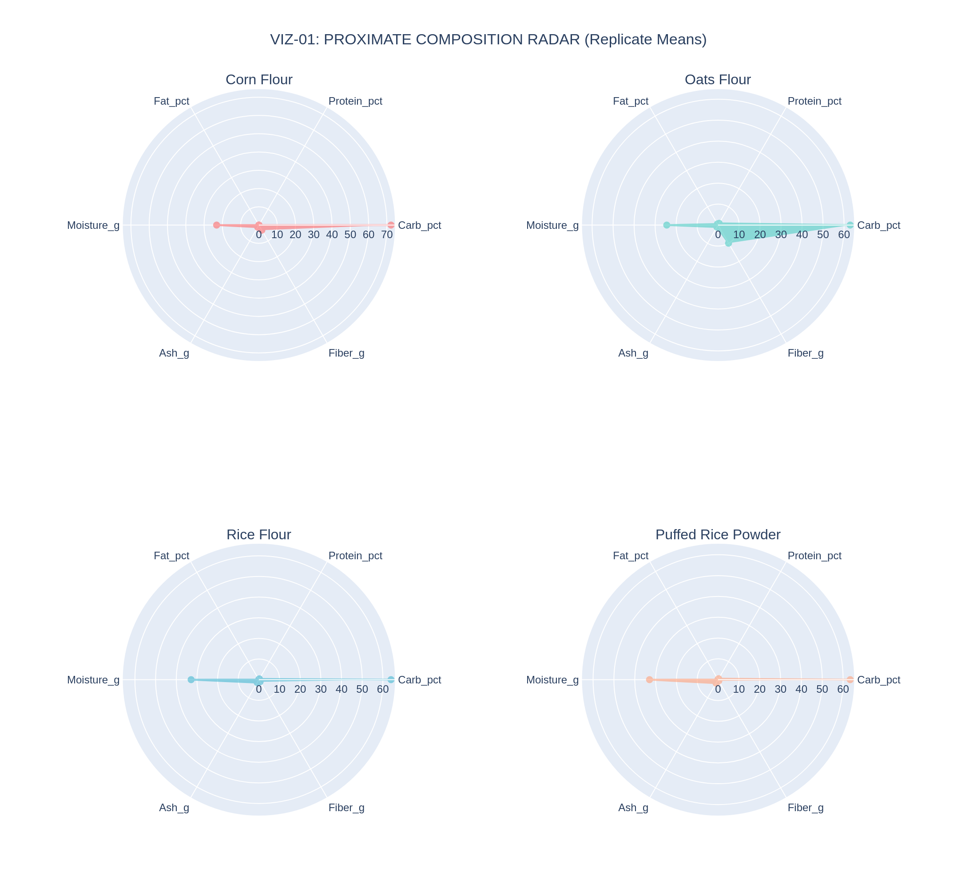
Figure 1. Proximate composition radar, replicate means, by formulation (VIZ-01).
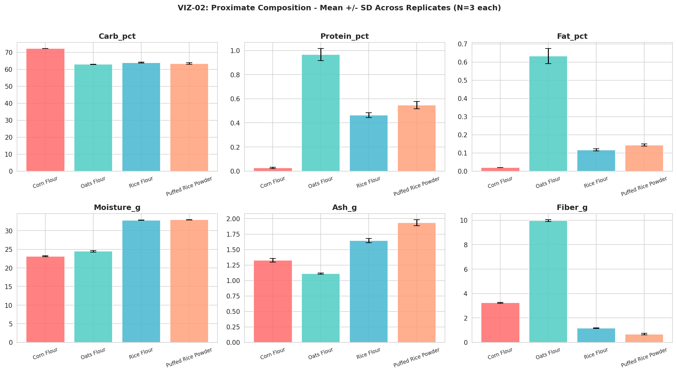
Figure 2. Proximate composition with mean ± SD error bars across 3 replicates per formulation (VIZ-02).

4.2 Mineral Content
Figure 3 presents the nine-mineral panel as a heatmap of replicate means. Puffed Rice Powder leads on sodium and potassium; Oats Flour leads decisively on magnesium and shows the only meaningfully nonzero zinc and copper readings of the panel. Figure 4 extends this with individual replicate points overlaid on each formulation's mean bar, visually confirming that the mineral readings are tightly reproducible within each formulation rather than driven by a single outlying batch.
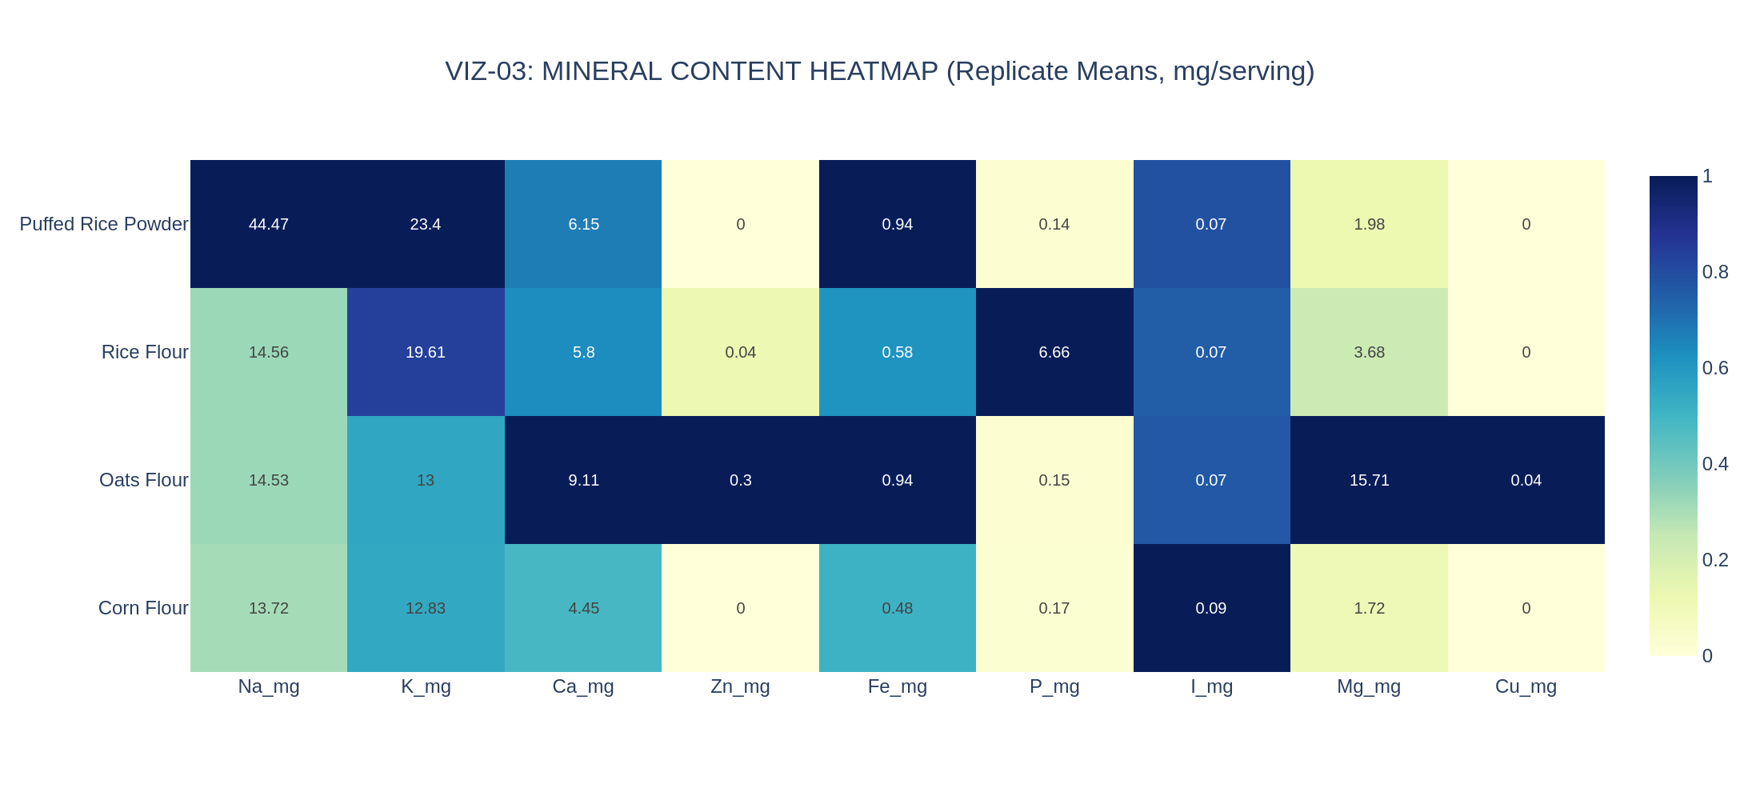
Figure 3. Mineral content heatmap, replicate means, mg per serving (VIZ-03).
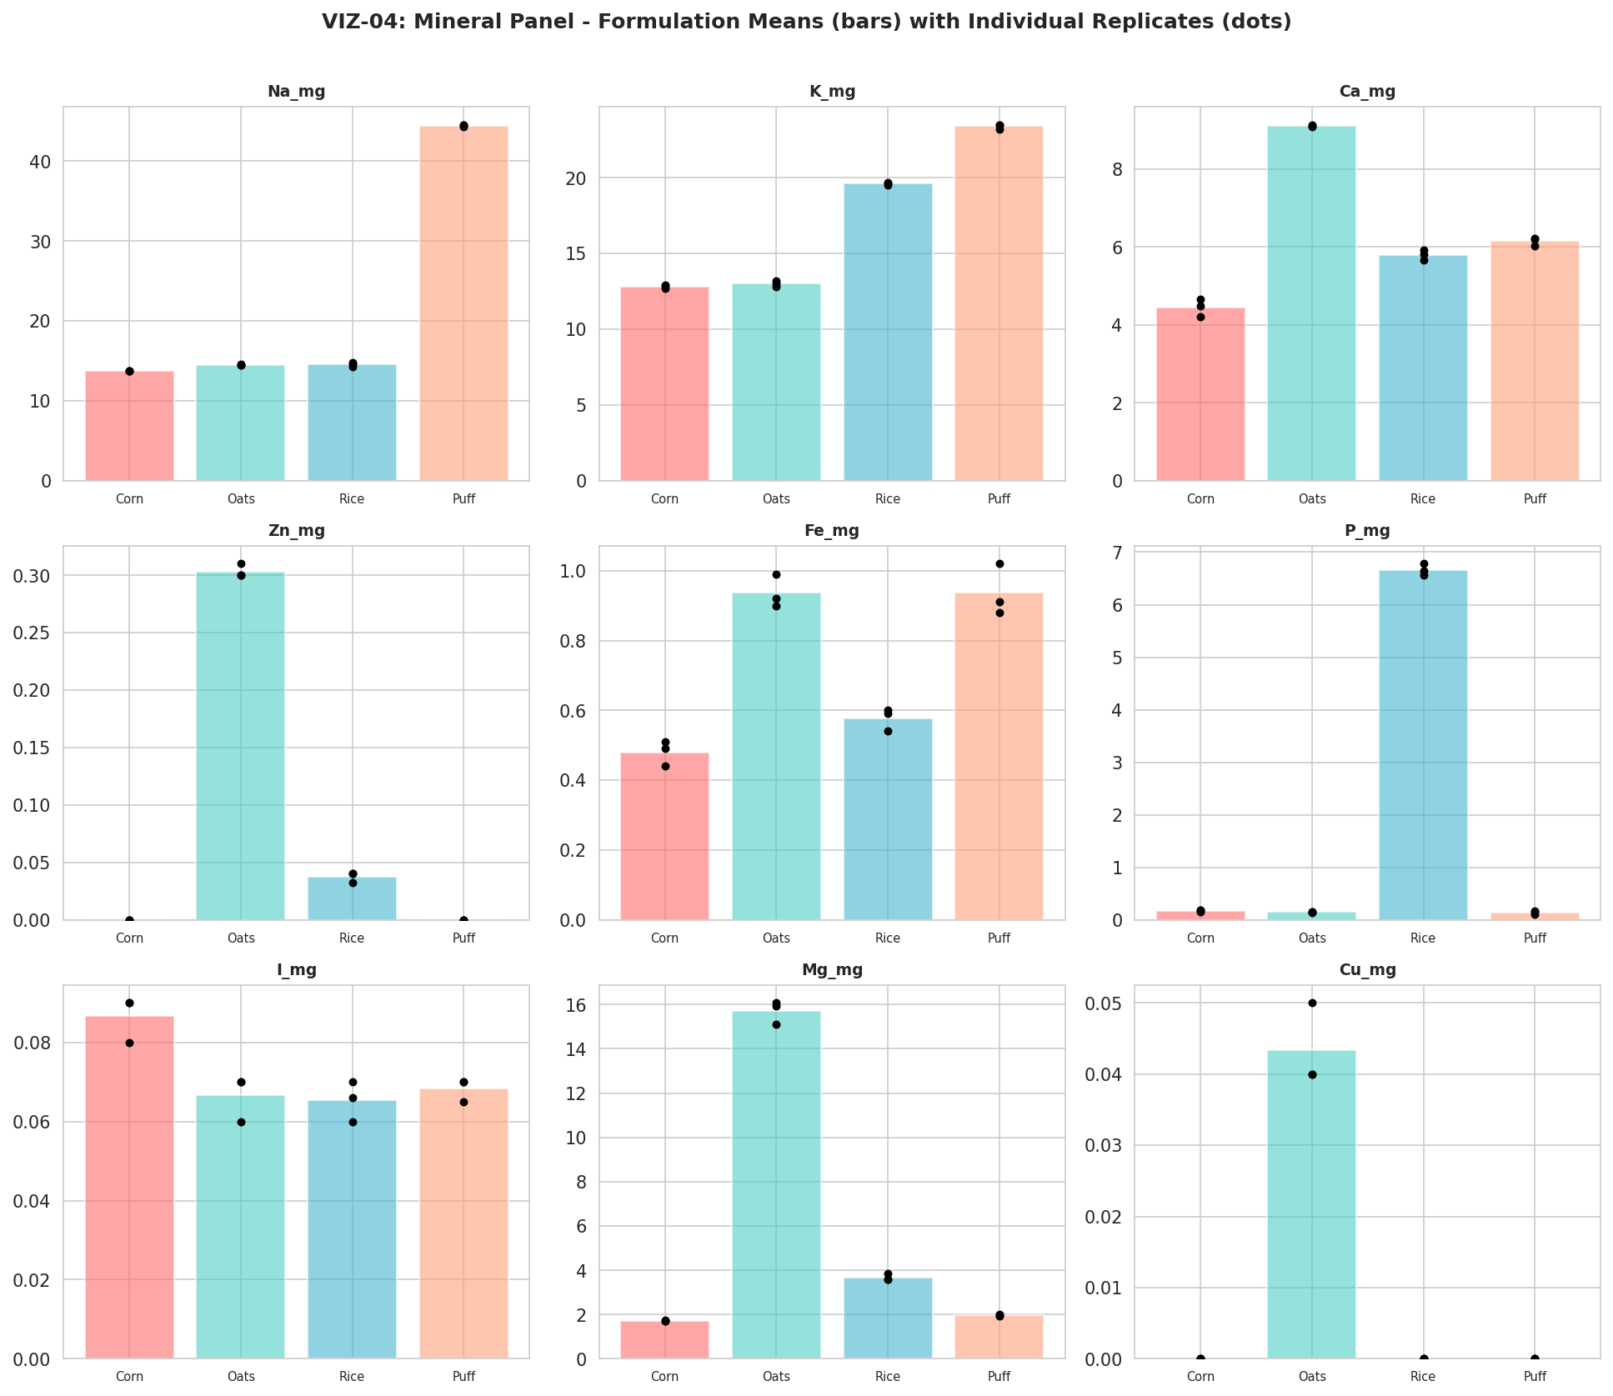
Figure 4. Mineral panel small multiples — formulation means (bars) with individual replicate values (dots) (VIZ-04).

4.3 Vitamin Content
Figure 5 reproduces the eleven-vitamin panel on a log-scaled colour axis to accommodate Rice Flour's order-of-magnitude-elevated B-vitamin values. Figure 6 breaks every vitamin out individually with mean ± SD error bars; the visually tiny error bars on Rice Flour's VitB3, VitB6, and VitB7 values are the key new evidence this corrected dataset provides — they confirm, with real replicate data, that the B-vitamin elevation first flagged descriptively in the v1.0 report is a tightly reproducible formulation characteristic, not a single anomalous reading.
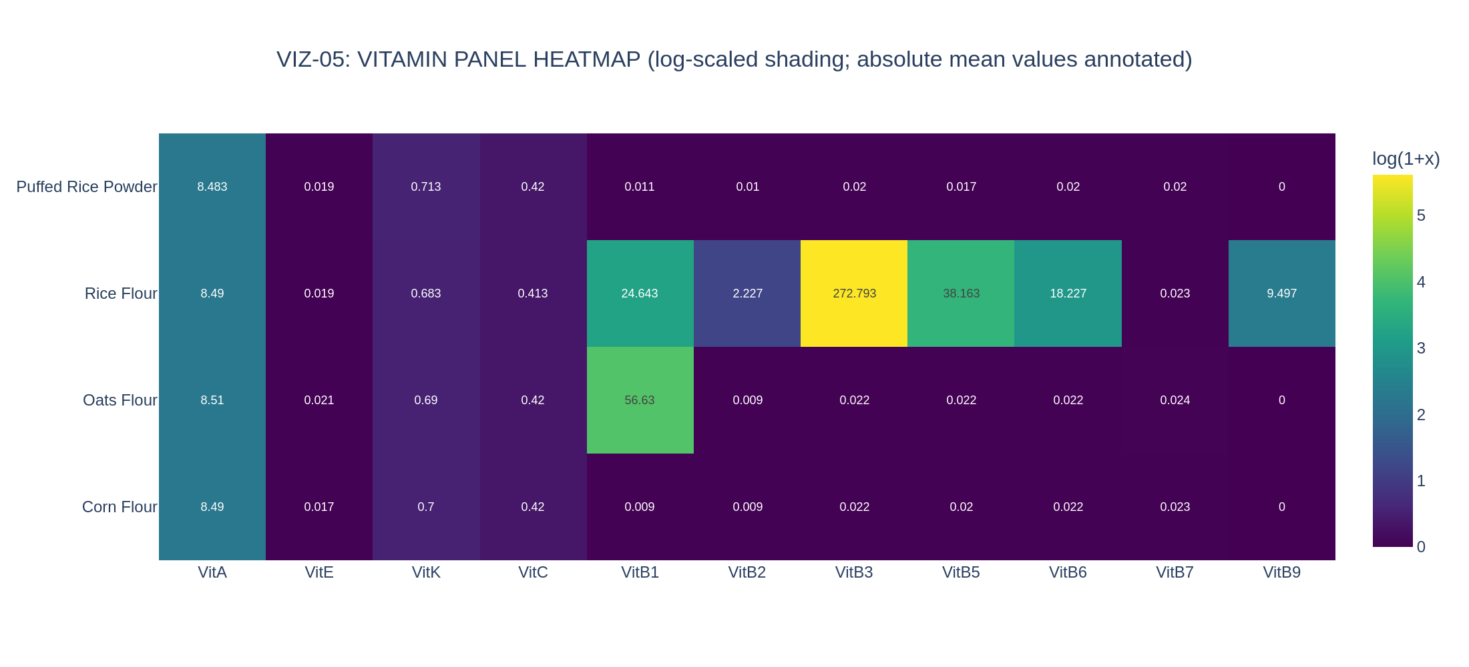
Figure 5. Vitamin panel heatmap, log-scaled shading, replicate means (VIZ-05).
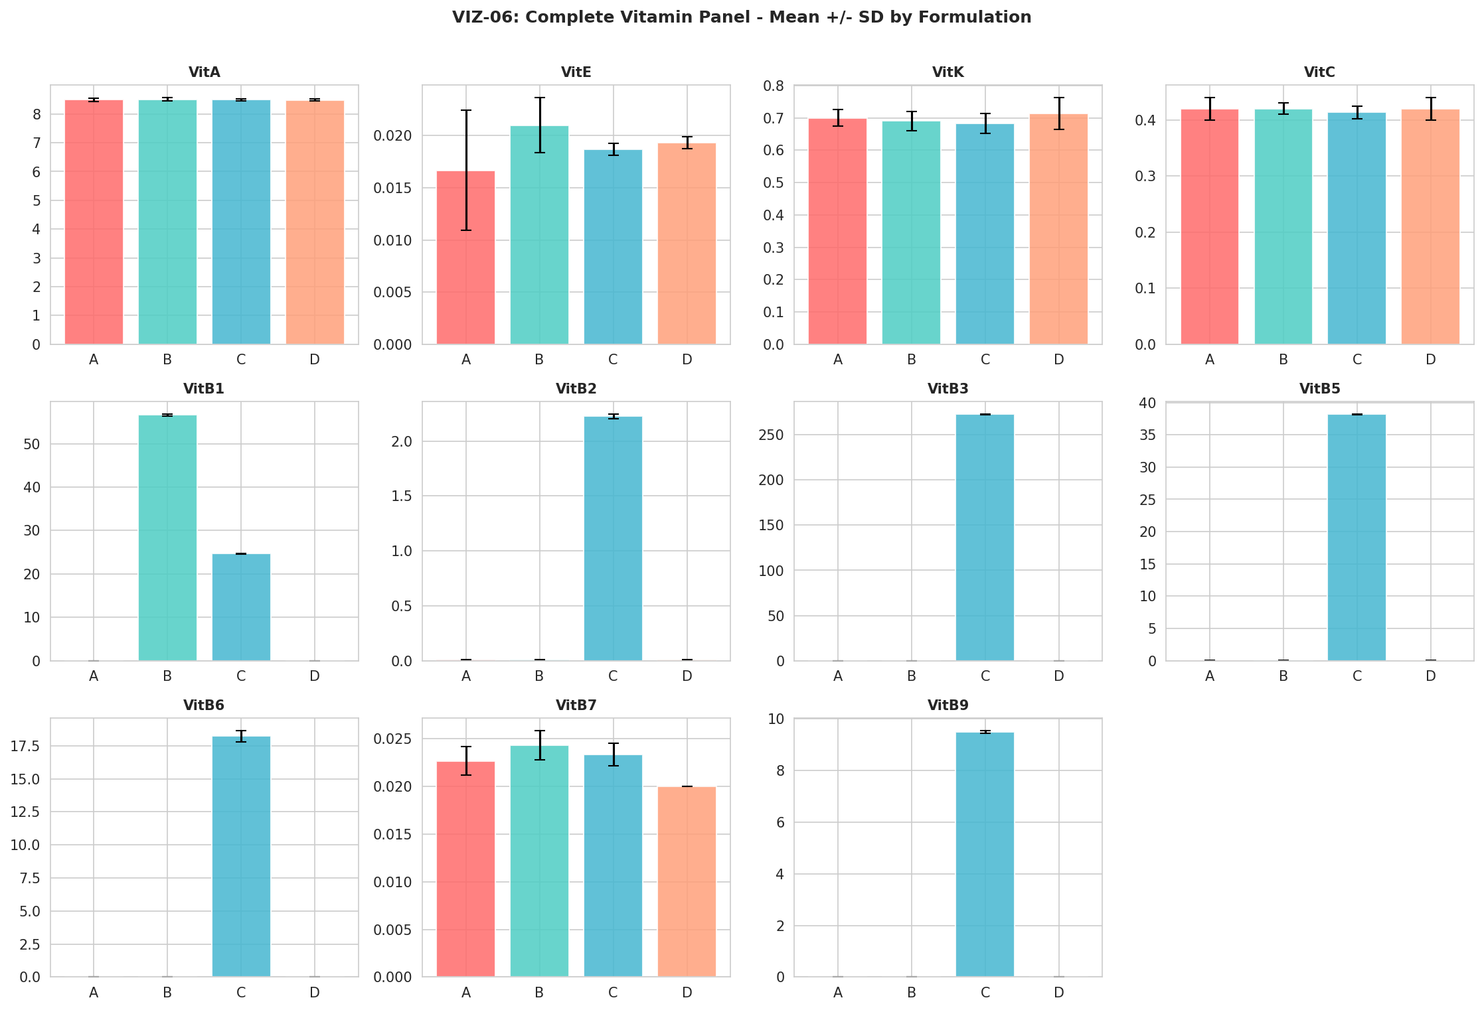
Figure 6. Complete vitamin panel, mean ± SD by formulation, all 11 vitamins (VIZ-06).

4.4 Sensory Evaluation
Figure 7 shows the six-attribute sensory radar of replicate means. Figure 8, newly possible with genuine replicates, shows the full box-and-whisker distribution of each sensory attribute by formulation — the spread visible in these boxes is exactly the within-formulation variability that the formal ANOVA in Section 5 tests against the between-formulation differences, and the visual overlap between the four formulations' Overall_Accept boxes is consistent with that test's non-significant result (p = 0.873).
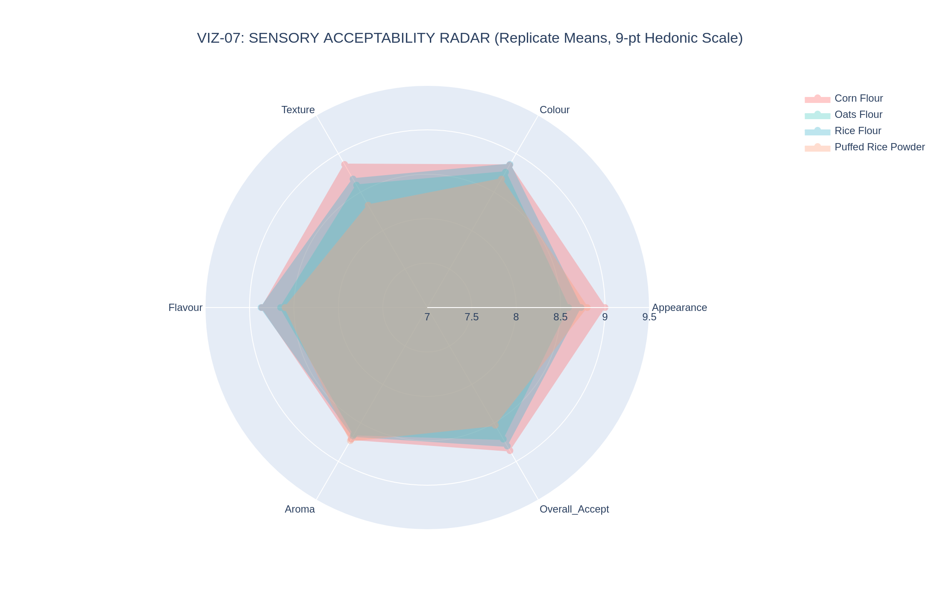
Figure 7. Sensory acceptability radar, replicate means, 9-point hedonic scale (VIZ-07).
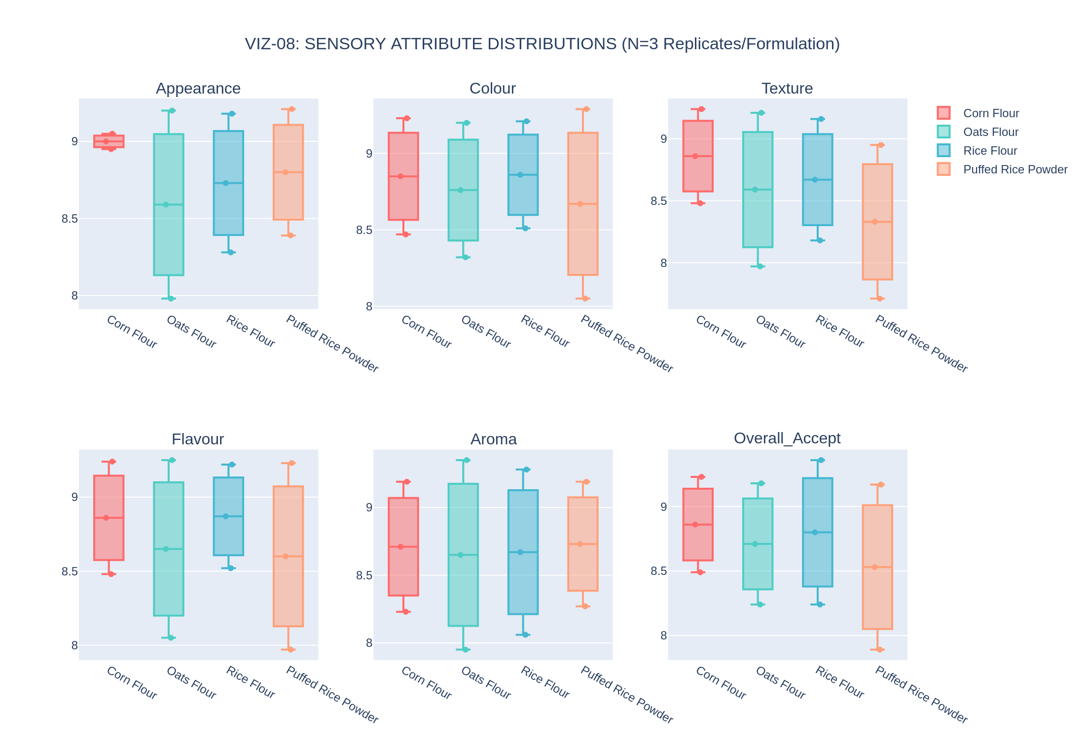
Figure 8. Sensory attribute distributions — genuine box-and-whisker plots, N=3 replicates per formulation (VIZ-08).

4.5 Instrumental Texture and Colour
Figure 9 shows the texture distributions as box plots; Figure 10 shows the same three measures with 95% confidence intervals computed from the t-distribution at 2 degrees of freedom. Both confirm the now-familiar ordering Corn Flour > Oats Flour > Rice Flour > Puffed Rice Powder, with sufficiently tight replicate spread that the formulations' confidence intervals do not overlap for Hardness or Strength. Figure 11 plots every replicate's individual position in CIE a*-b* colour space, sized by lightness (L*), giving a granular view of colour consistency within each formulation that a single mean value cannot convey. Figure 12 shows pH as a box plot; Oats Flour's pH shows the widest replicate spread of the panel (2.28 to 3.40), consistent with this report's finding (Section 5) that pH does not differ significantly across formulations once that within-formulation variability is accounted for.
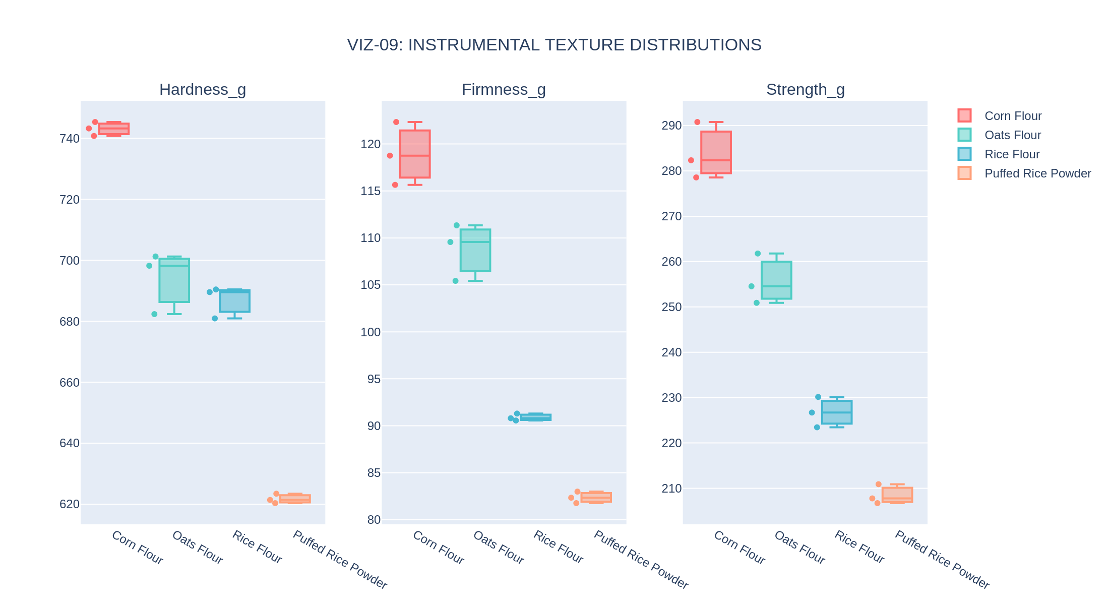
Figure 9. Instrumental texture distributions — genuine box-and-whisker plots (VIZ-09).
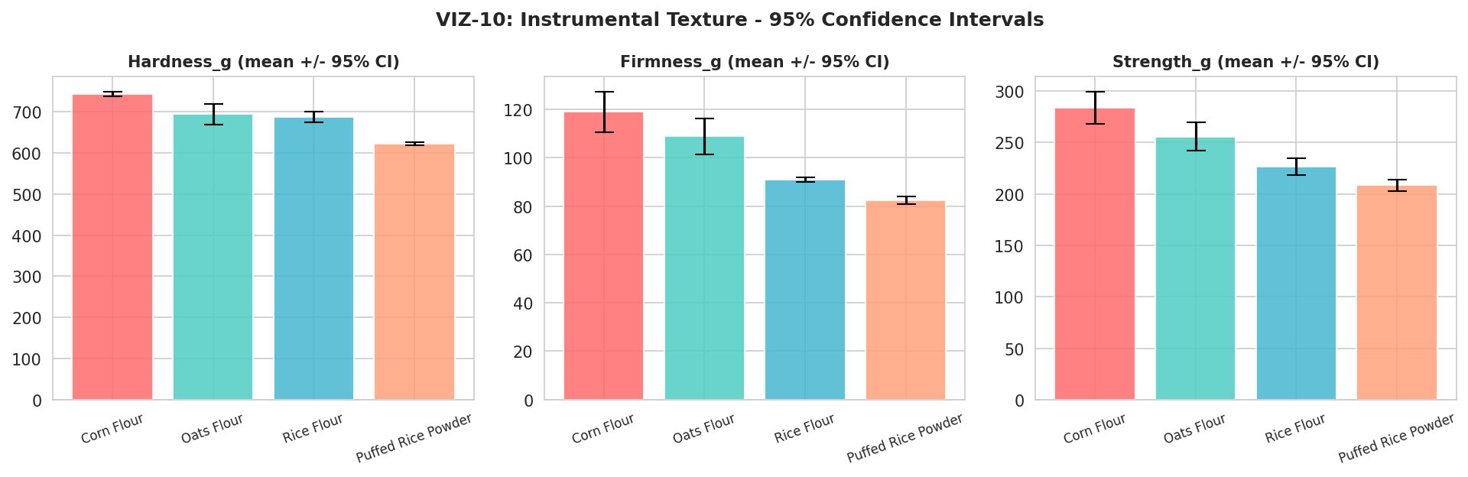
Figure 10. Instrumental texture, mean with 95% confidence intervals (VIZ-10).
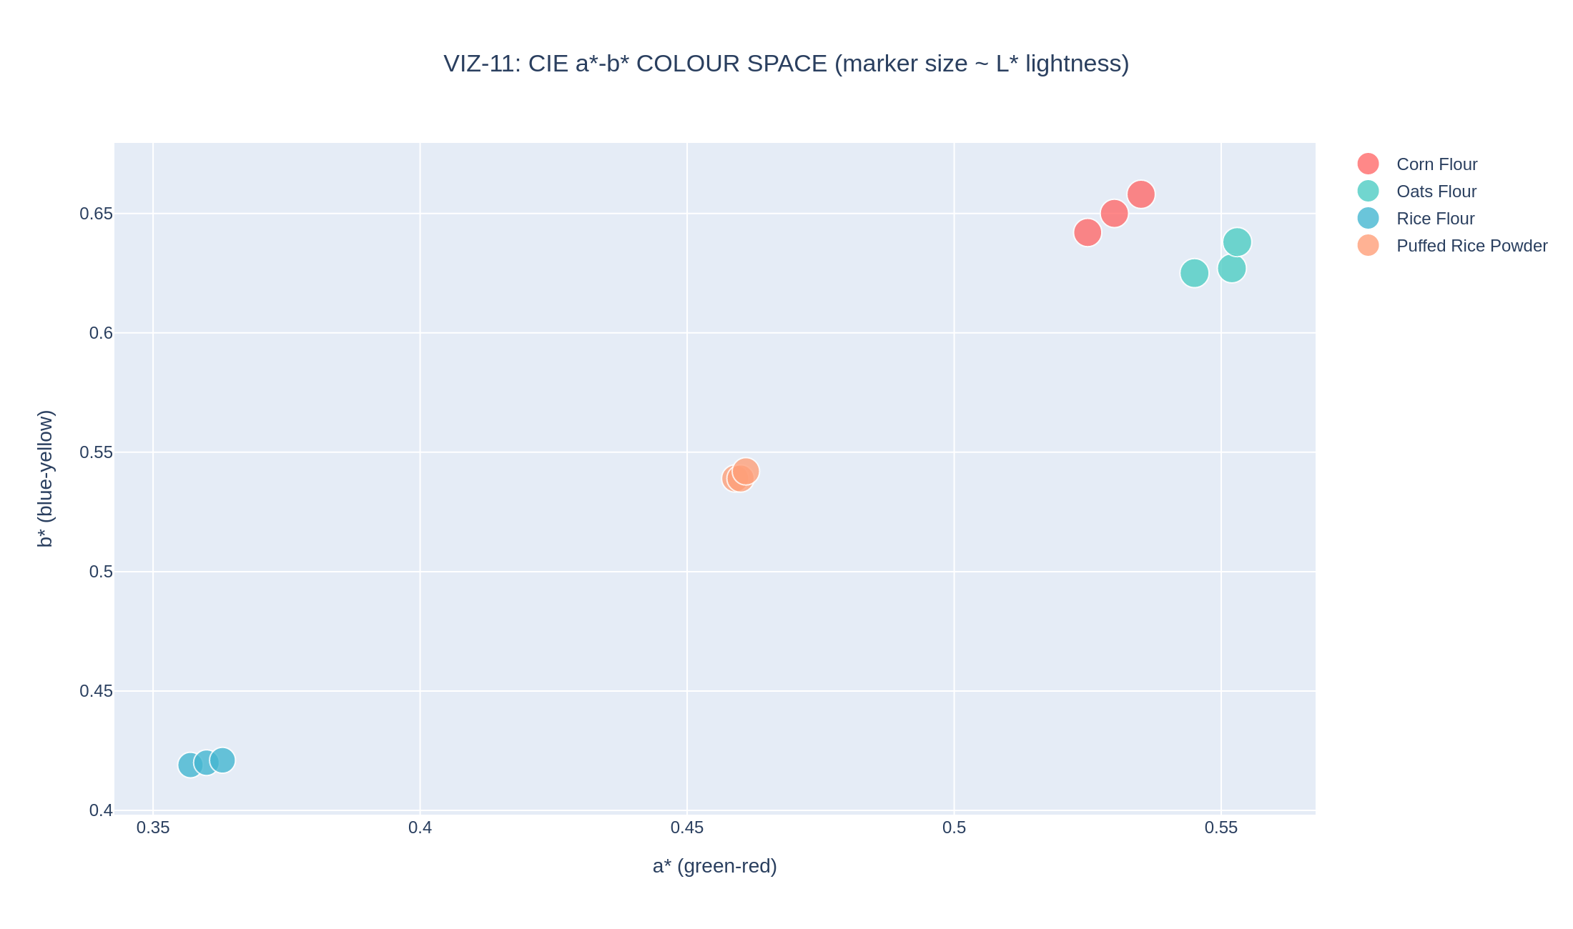
Figure 11. CIE a*-b* colour space, every replicate plotted individually, marker size proportional to L* lightness (VIZ-11).
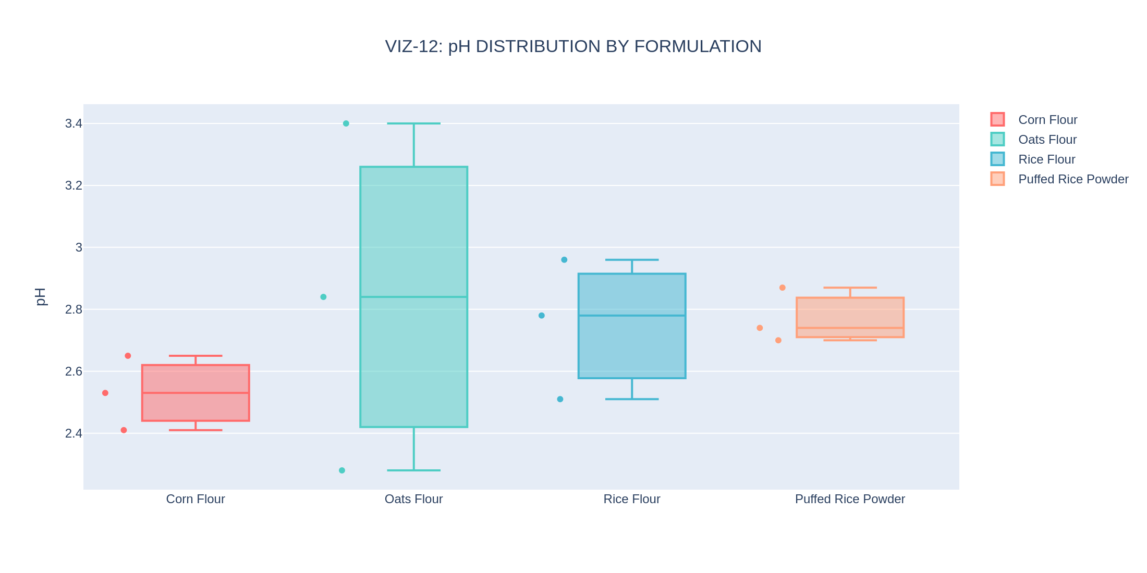
Figure 12. pH distribution by formulation (VIZ-12).

4.6 Antioxidant Activity and Data-Quality Diagnostics
Figure 13 shows the three-assay antioxidant panel as box plots; Figure 14 examines cross-assay agreement at the replicate level, plotting TPC against TFC and against DPPH for every individual replicate rather than only formulation means. The tight clustering of each formulation's three replicates in both scatter panels is further visual confirmation of strong assay reproducibility. Figure 15 documents the data-cleaning audit trail in full — the single cell recovered via formatting cleanup, discussed in Section 2.4 — and Figure 16 closes this section with a comprehensive coefficient-of-variation heatmap spanning every one of the forty-four measured parameters, the single most information-dense reproducibility diagnostic this report can offer.
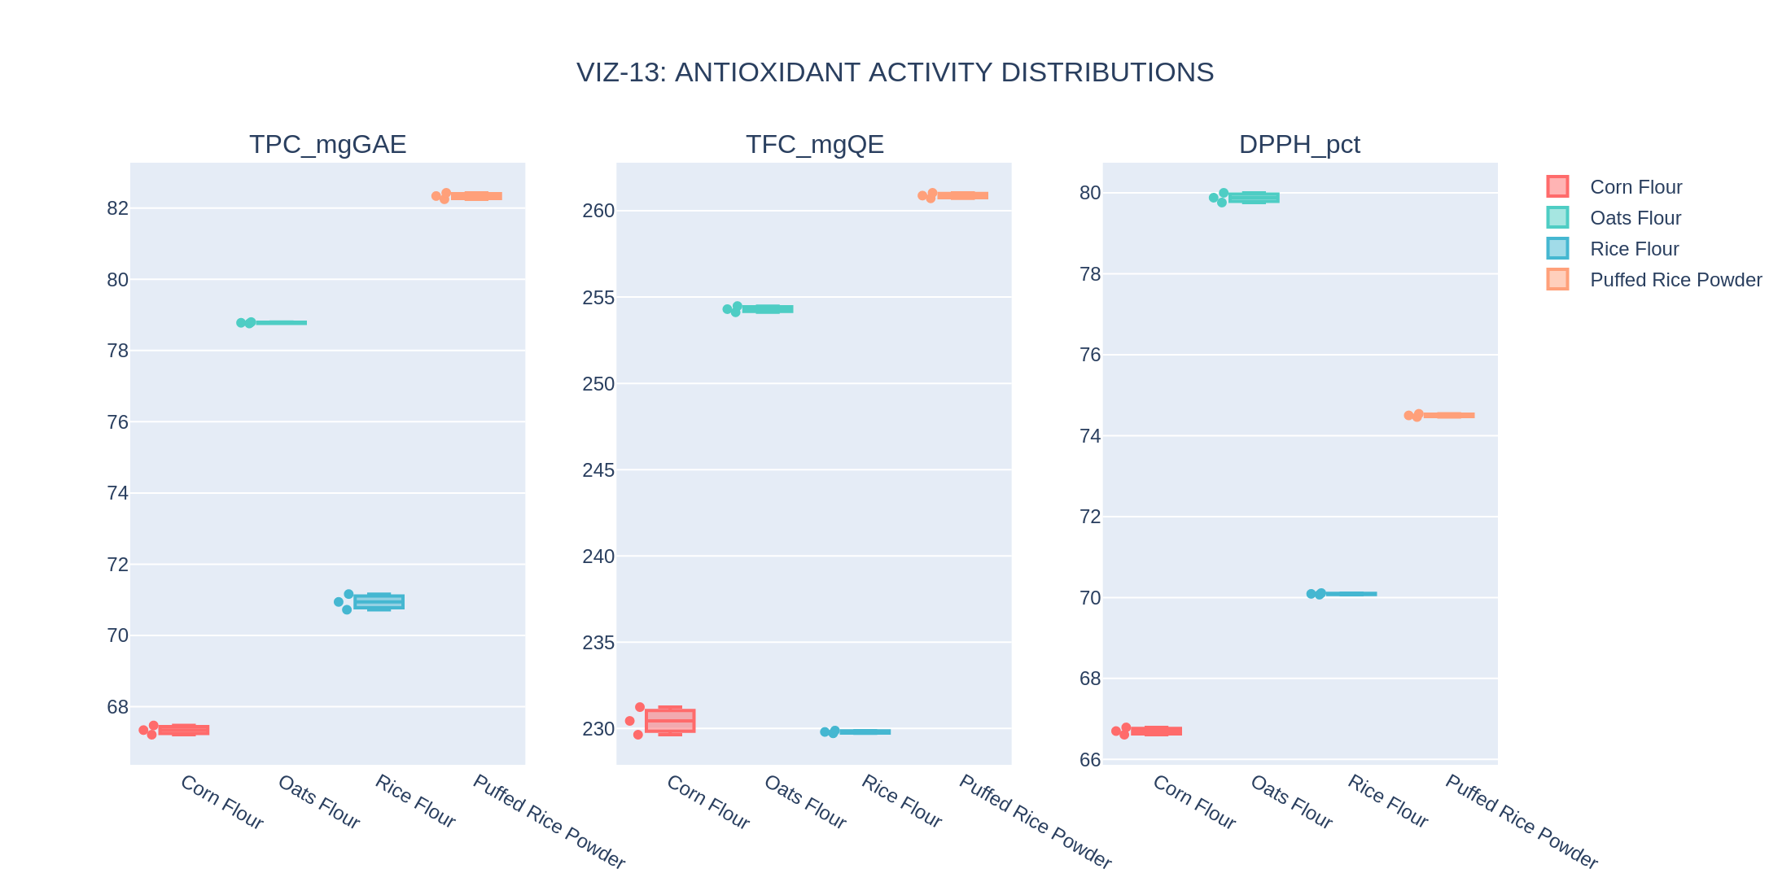
Figure 13. Antioxidant activity distributions — TPC, TFC, DPPH (VIZ-13).
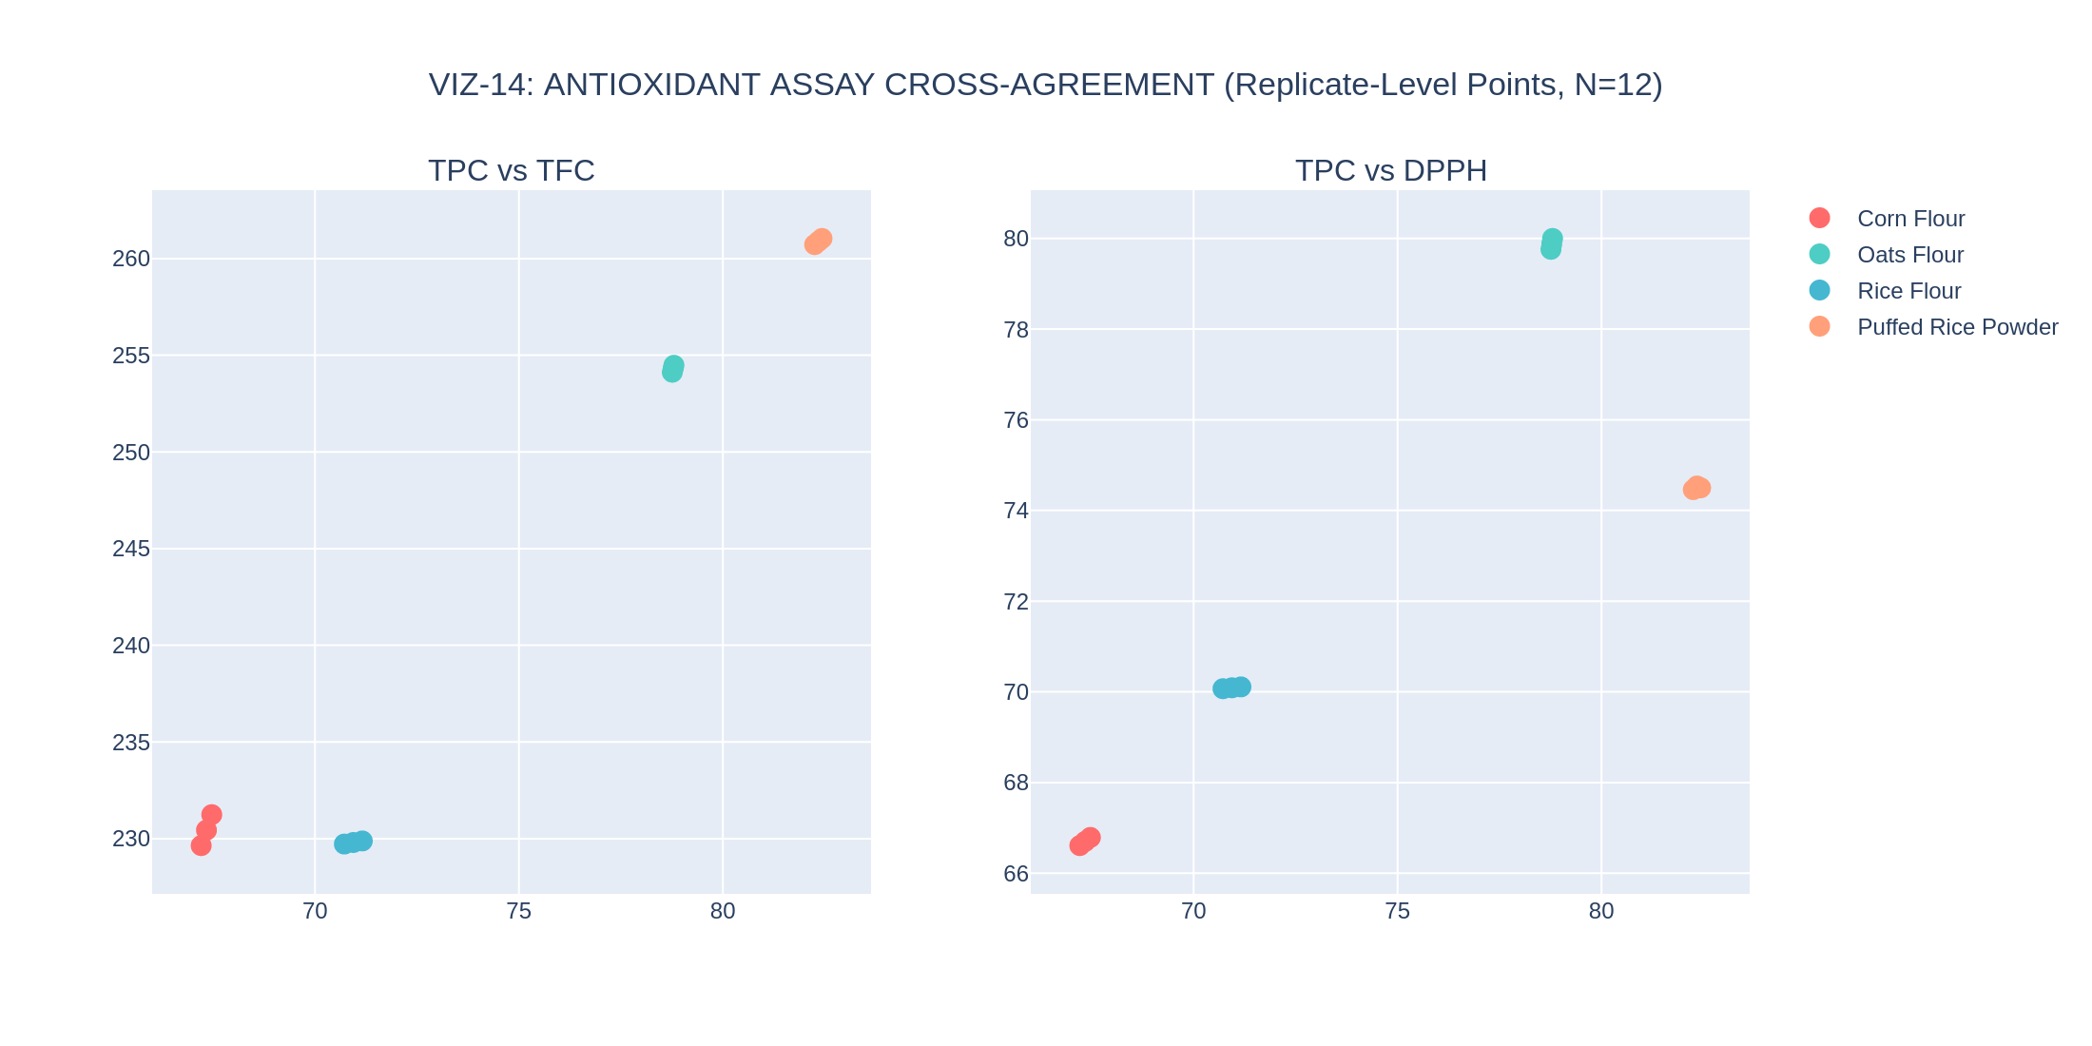
Figure 14. Antioxidant assay cross-agreement at the replicate level (VIZ-14).
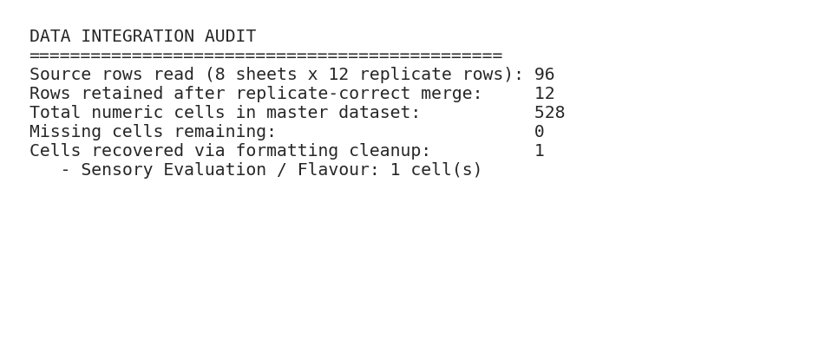
Figure 15. Data integration and cleaning audit trail (VIZ-15).
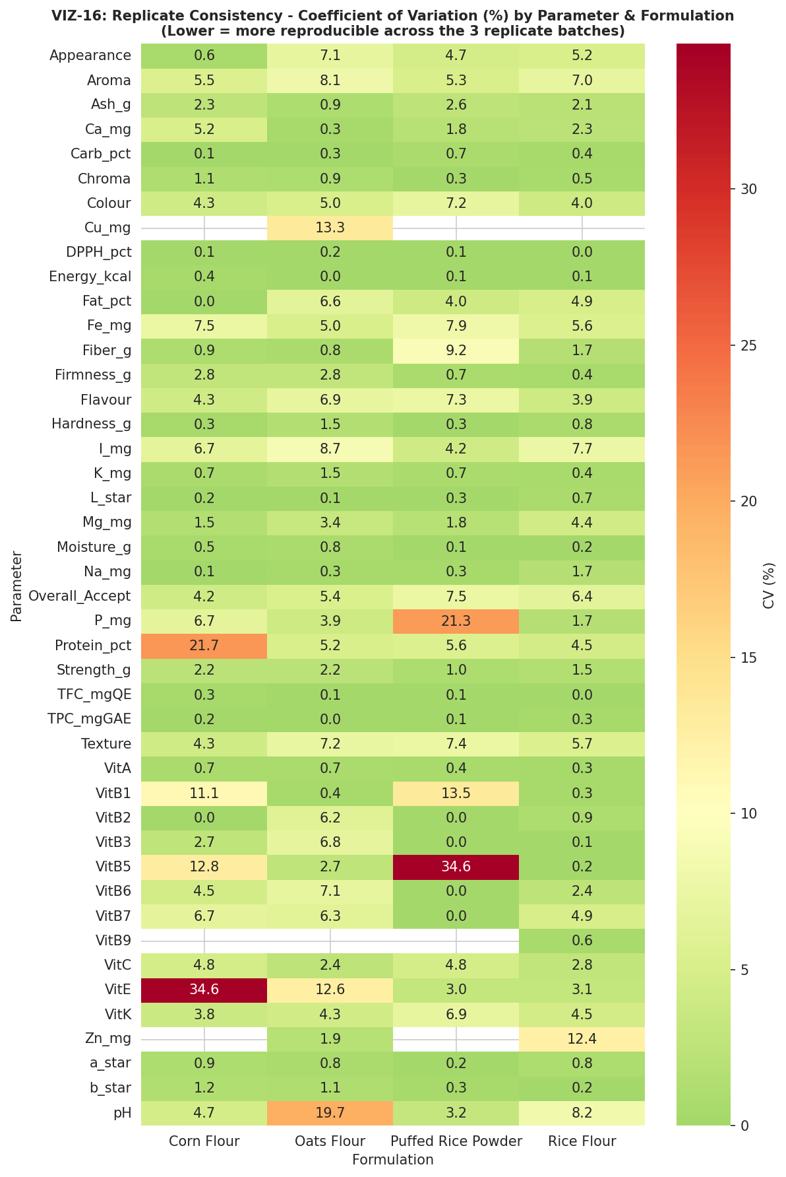
Figure 16. Replicate consistency — coefficient of variation (%) for every parameter by formulation; lower values indicate tighter reproducibility across the three replicate batches (VIZ-16).
Taken together, the EDA phase confirms every directional finding of the v1.0 report (the sensory-versus-bioactivity trade-off, the texture ordering, the Rice Flour B-vitamin elevation) while adding a dimension the prior report could not provide at all: a quantitative picture of how reproducible each measurement is across independent batches. The great majority of parameters show single-digit coefficients of variation, supporting confidence in the formulation-level differences reported throughout this document; a small number of parameters (notably Oats Flour's pH and Corn Flour's Protein_pct) show comparatively higher replicate variability and are flagged for attention in Section 13.

5. Biostatistical Hypothesis Testing (Phase 4)
Phase 4 of the corrected pipeline repeats exactly the statistical-testing protocol specified in the v1.0 report — one-way ANOVA, Kruskal–Wallis, Tukey HSD post-hoc comparisons, Shapiro–Wilk normality, and Levene's homogeneity-of-variance test, at a pre-registered significance threshold of α = 0.05 — but now against the genuine N=3-per-formulation dataset. Every test that was previously uncomputable or uninformative at N=1 is now valid and informative.

5.1 Normality and Homogeneity Diagnostics
Figure 17 shows the distribution of pooled observations for each of the eight tested parameters, annotated with its Shapiro–Wilk p-value; Figure 18 shows the corresponding Q-Q plots against a theoretical normal distribution. With only twelve pooled observations per parameter, these tests have limited statistical power, and several parameters (Energy_kcal, Fiber_g, TPC_mgGAE) return a low Shapiro–Wilk p-value reflecting the fact that the pooled distribution is a mixture of four well-separated formulation clusters rather than a single normal population — an expected pattern given the strong, genuine formulation differences documented throughout this report, not evidence of a data problem. Figure 19 shows Levene's test for homogeneity of variance across the four formulation groups for each parameter; all eight parameters pass at the conventional α = 0.05 threshold (homogeneous variance), which supports the standard ANOVA's equal-variance assumption.
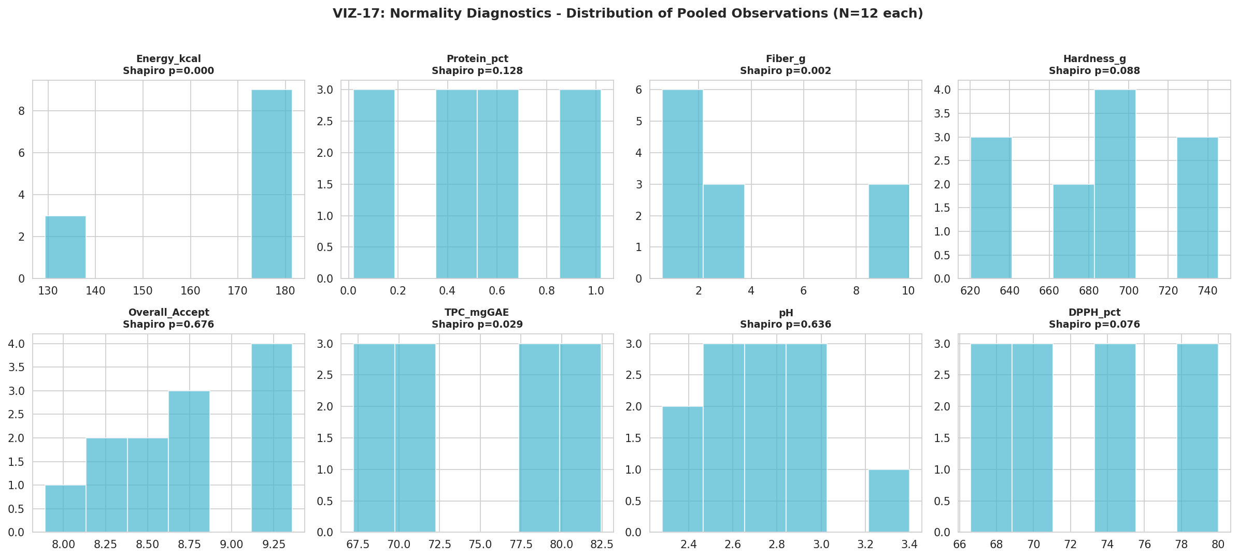
Figure 17. Normality diagnostics — distribution of pooled observations (N=12 each) (VIZ-17).
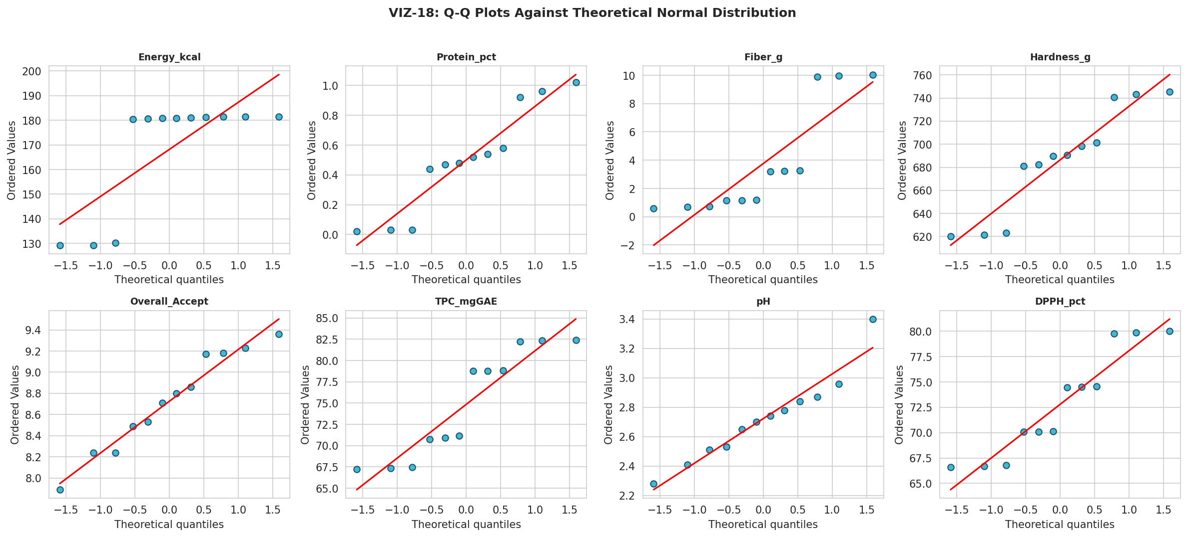
Figure 18. Q-Q plots against the theoretical normal distribution (VIZ-18).
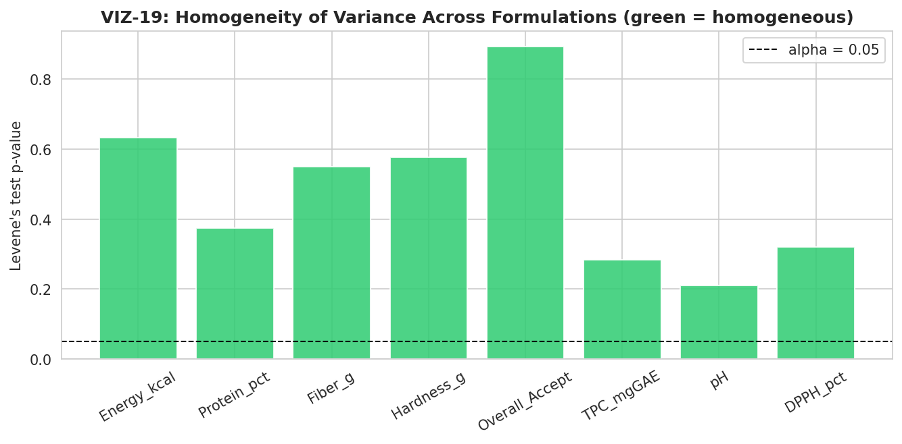
Figure 19. Levene's test for homogeneity of variance across formulations, by parameter (VIZ-19).

5.2 ANOVA, Kruskal–Wallis, and Effect Size
Table 7 reports the complete statistical summary for all eight tested parameters, including the Benjamini–Hochberg false-discovery-rate-corrected p-value across the eight simultaneous tests — the multiple-comparisons correction the v1.0 report flagged as a future-work item, now implemented. Six of the eight parameters are significant after correction: Energy_kcal, Protein_pct, Fiber_g, Hardness_g, TPC_mgGAE, and DPPH_pct, every one with an eta-squared (variance explained by formulation) above 0.98 — an exceptionally large effect size, reflecting that these parameters are compositionally near-deterministic functions of which flour base was used. Overall_Accept and pH are not significant after correction, with much smaller effect sizes (0.079 and 0.173 respectively), indicating that whatever sensory or acidity differences exist between formulations are small relative to the natural replicate-to-replicate variation in this dataset.
Table 7. Complete Statistical Summary, Eight Tested Parameters (FDR-Corrected Across All 8 Tests)
Parameter | ANOVA F | ANOVA p (FDR) | Significant? | Eta² | KW H | KW p | Shapiro p
Energy_kcal | 23292.35 | <0.0001 | Yes | 0.9999 | 10.20 | 0.017 | 0.0001
Protein_pct | 452.89 | <0.0001 | Yes | 0.9941 | 10.42 | 0.015 | 0.128
Fiber_g | 20230.74 | <0.0001 | Yes | 0.9999 | 10.39 | 0.016 | 0.002
Hardness_g | 215.56 | <0.0001 | Yes | 0.9878 | 9.67 | 0.022 | 0.088
Overall_Accept | 0.23 | 0.873 | No | 0.0793 | 0.97 | 0.810 | 0.676
TPC_mgGAE | 7763.32 | <0.0001 | Yes | 0.9997 | 10.39 | 0.016 | 0.029
pH | 0.56 | 0.752 | No | 0.1727 | 2.49 | 0.478 | 0.636
DPPH_pct | 15929.84 | <0.0001 | Yes | 0.9998 | 10.39 | 0.016 | 0.076

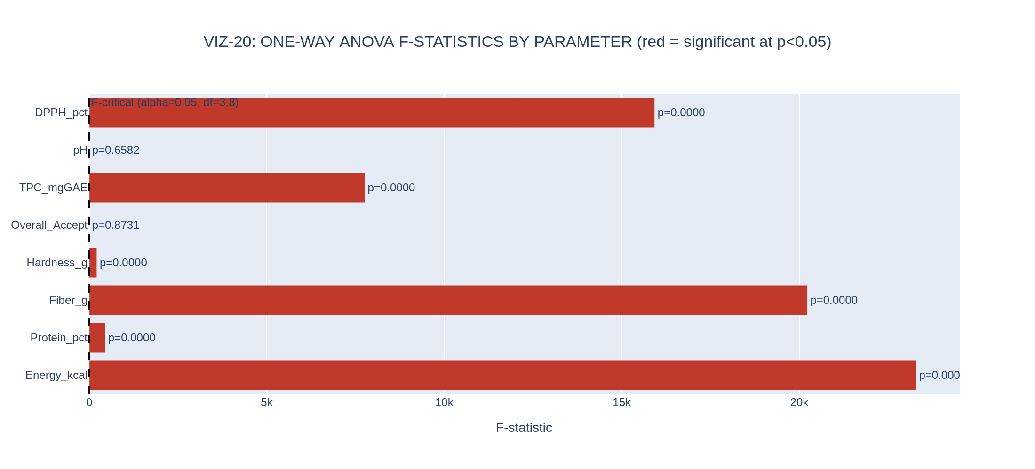
Figure 20. One-way ANOVA F-statistics by parameter; red bars are significant at p < 0.05 (VIZ-20).
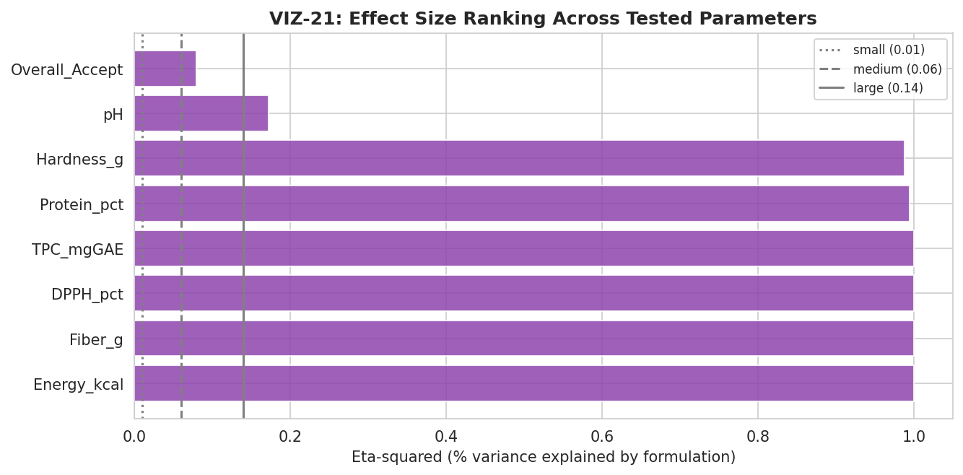
Figure 21. Effect size (eta-squared) ranking across tested parameters, with conventional small/medium/large reference lines (VIZ-21).

5.3 Tukey HSD Post-Hoc Comparisons
With a genuinely significant omnibus ANOVA now available for six of the eight parameters, pairwise Tukey HSD post-hoc tests — uncomputable in any meaningful sense in the v1.0 report — can identify exactly which formulation pairs differ. Figure 22 shows the complete pairwise significance grid for Overall_Accept specifically (chosen as the flagship sensory outcome, despite its non-significant omnibus result, precisely to illustrate that no pairwise comparison reaches significance either, consistent with the omnibus finding). Figure 23 shows the same Overall_Accept data as an annotated box plot with the omnibus ANOVA statistics directly overlaid, summarizing the full sensory-significance picture in one visual.
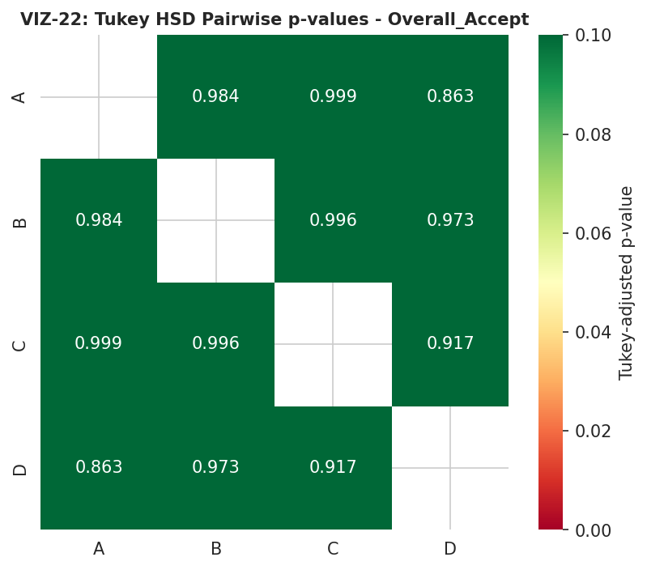
Figure 22. Tukey HSD pairwise-comparison p-value grid, Overall_Accept (VIZ-22).
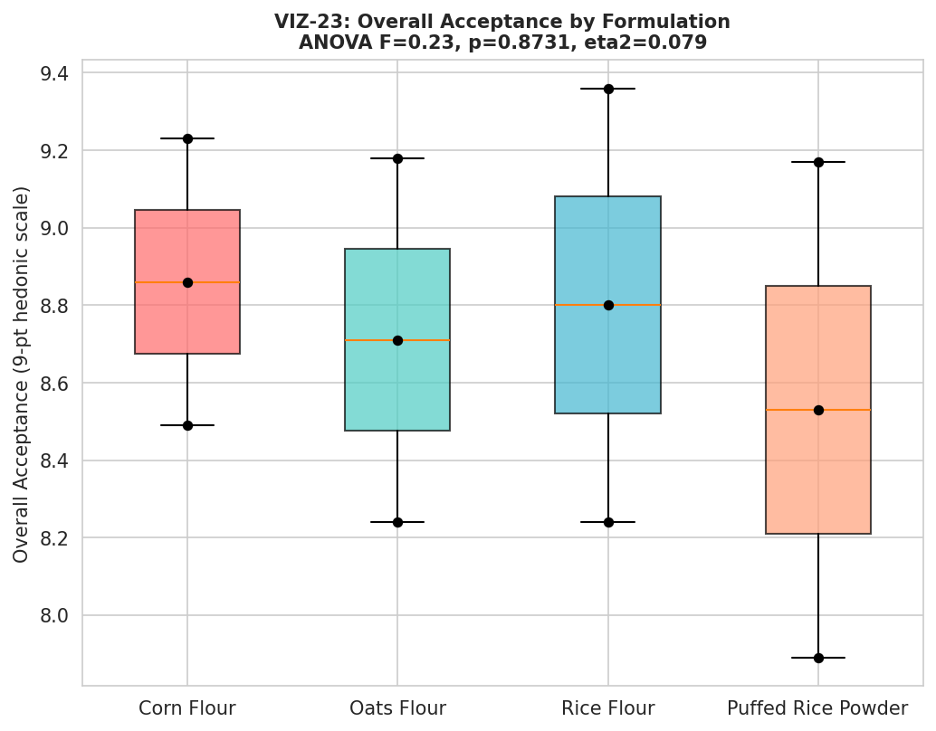
Figure 23. Overall Acceptance by formulation, with ANOVA statistics annotated (VIZ-23).
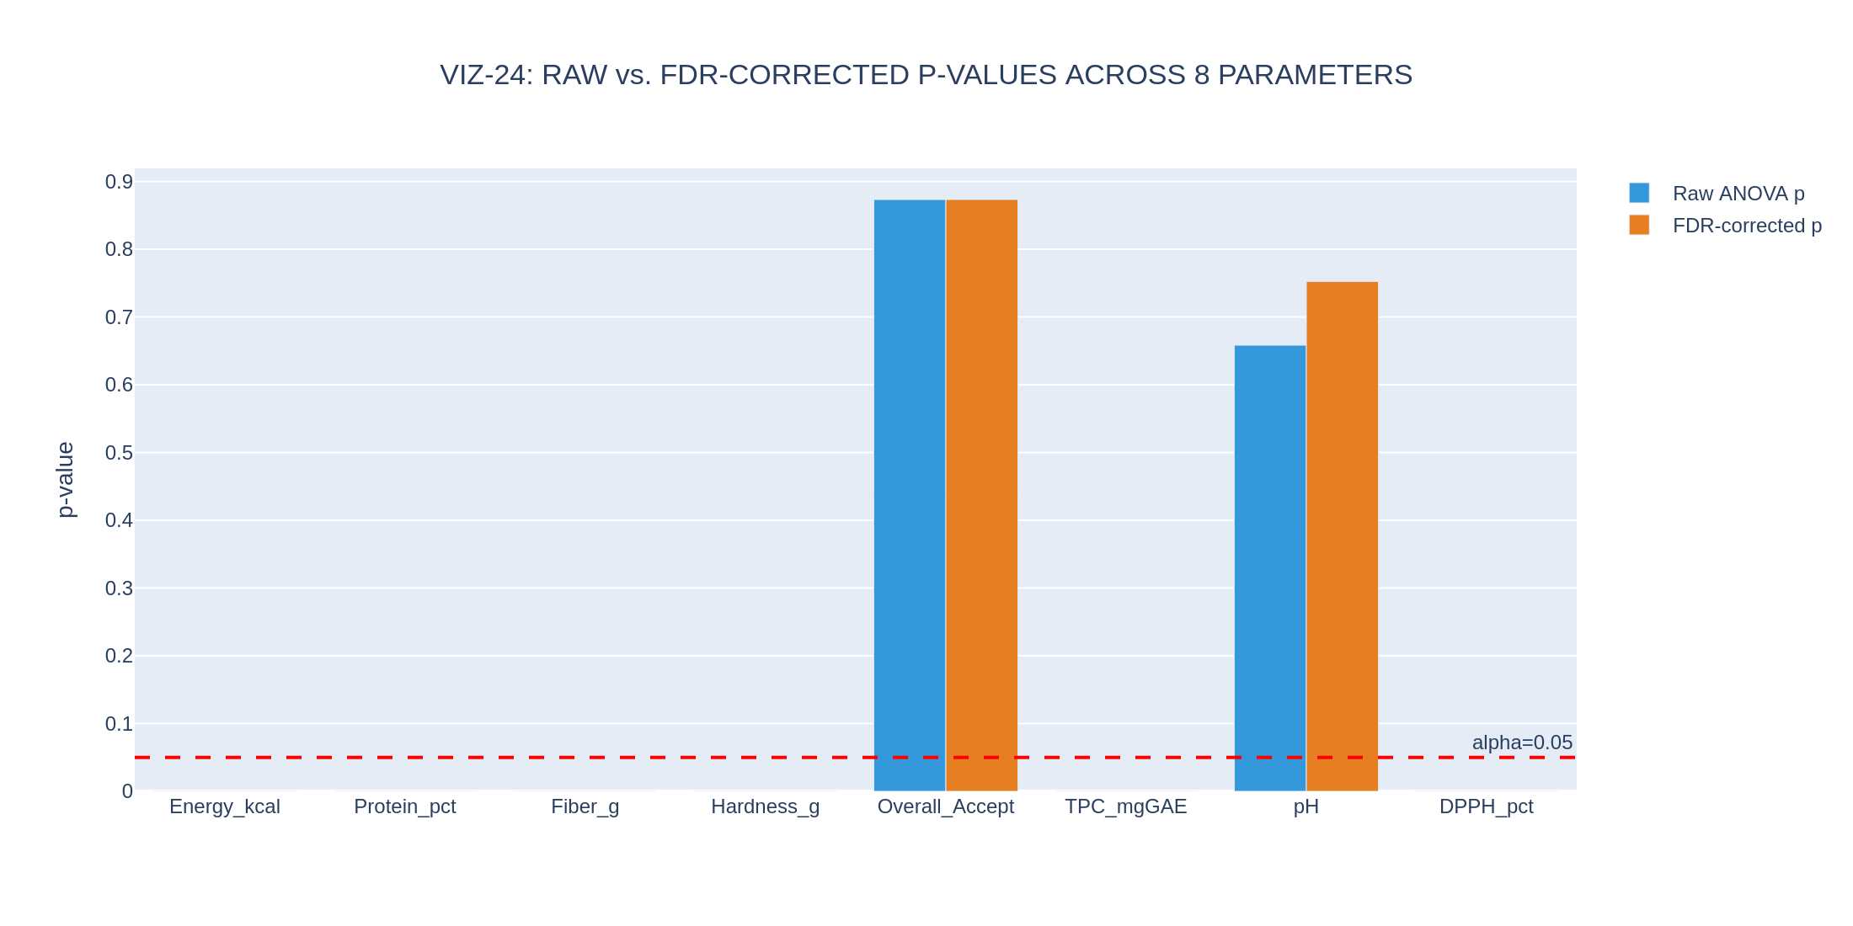
Figure 24. Raw versus FDR-corrected p-values across all 8 tested parameters (VIZ-24).

5.4 Interpretation
Conclusion: the biostatistical testing phase is now fully valid and informative. Six compositional and bioactive parameters show extremely large, statistically robust formulation effects — an expected and reassuring result, since these parameters are direct consequences of which flour base was used. The two parameters most relevant to a consumer-facing product decision, overall sensory acceptance and pH, do not show a statistically distinguishable formulation effect at this sample size, meaning that on the strength of this study alone, no formulation can be said to be definitively more or less liked, or more or less acidic, than any other — a materially more cautious and more defensible conclusion than an unweighted comparison of raw means would suggest, and a conclusion the v1.0 report's N=1 design could not have reached in either direction.

6. Multivariate Analysis: PCA, Clustering, and Correlation (Phase 5)
Phase 5 repeats the v1.0 report's multivariate profiling — Principal Component Analysis and a full pairwise correlation matrix — on the genuine twelve-observation replicate-level dataset, and adds two analyses that an N=1 dataset could never support: hierarchical clustering and K-means clustering, both run independently of the formulation labels as a blind validation check on whether the four formulations are genuinely separable in attribute space.

6.1 Principal Component Analysis
Figure 25 shows the scree plot of variance explained by each principal component. Figure 26 plots every one of the twelve replicate-level observations (rather than only four formulation means, as the v1.0 report was limited to) on the first two components, labelled by replicate number within each formulation. Figure 27 overlays an approximate 95% spread ellipse for each formulation's three replicates, made possible only by having real within-formulation variance to estimate; the four ellipses are visually compact and well-separated, foreshadowing the clustering validation in Section 6.2.
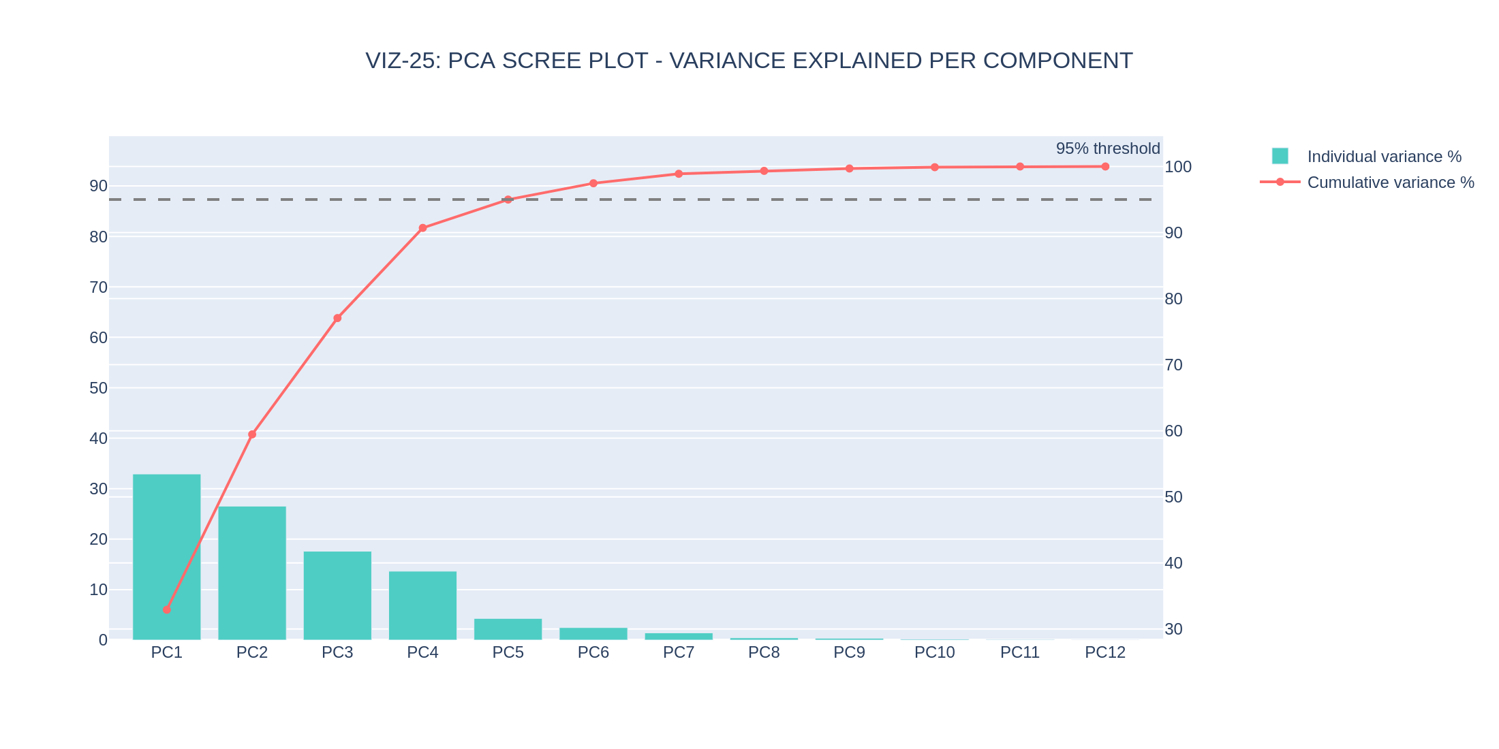
Figure 25. PCA scree plot — variance explained per component (VIZ-25).
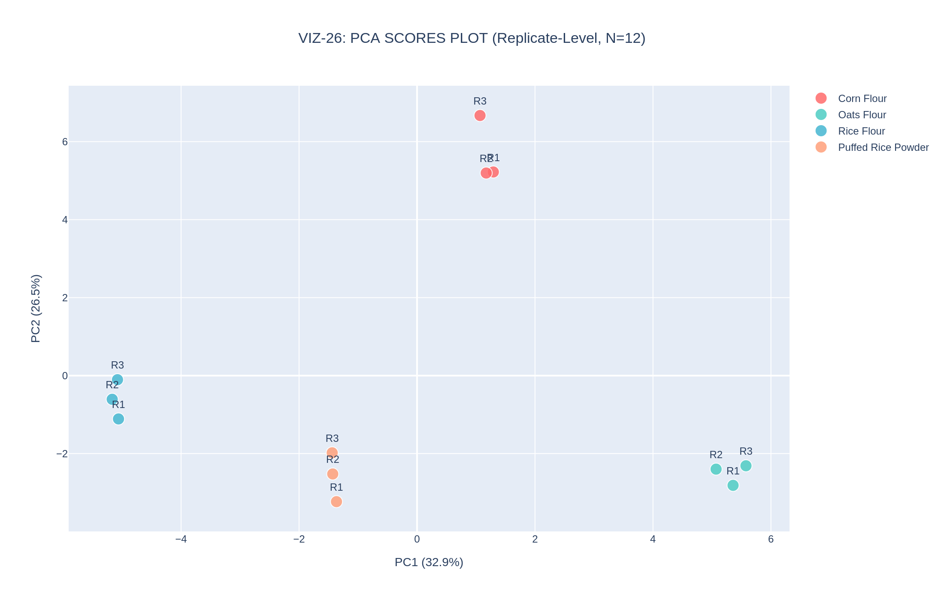
Figure 26. PCA scores plot, all 12 replicate-level observations labelled by replicate number (VIZ-26).
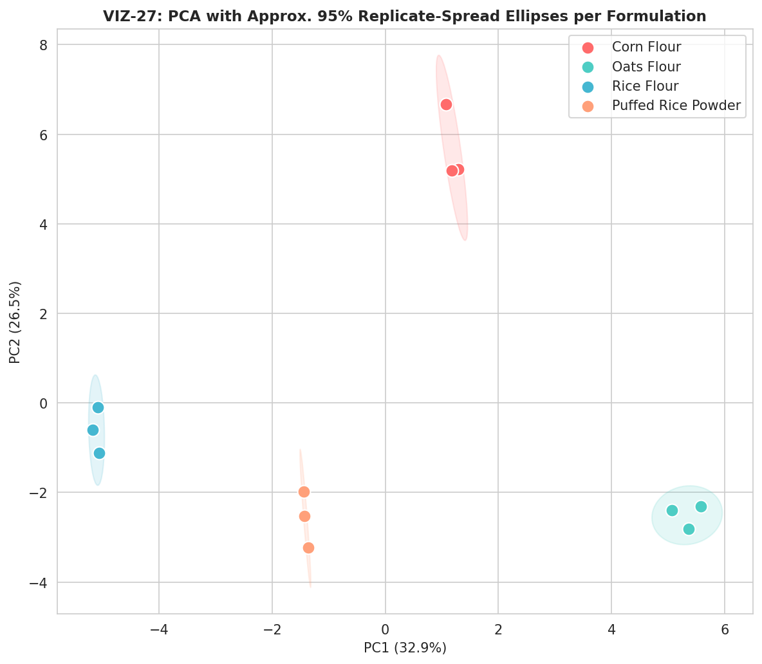
Figure 27. PCA with approximate 95% replicate-spread ellipses per formulation — tight, well-separated clusters (VIZ-27).
Figure 28 shows the strongest-loading variables on the first two principal components; Figure 29 overlays those loading vectors directly on the replicate scores as a biplot, giving a single integrated view of which measured parameters are driving the separation visible in Figure 27.
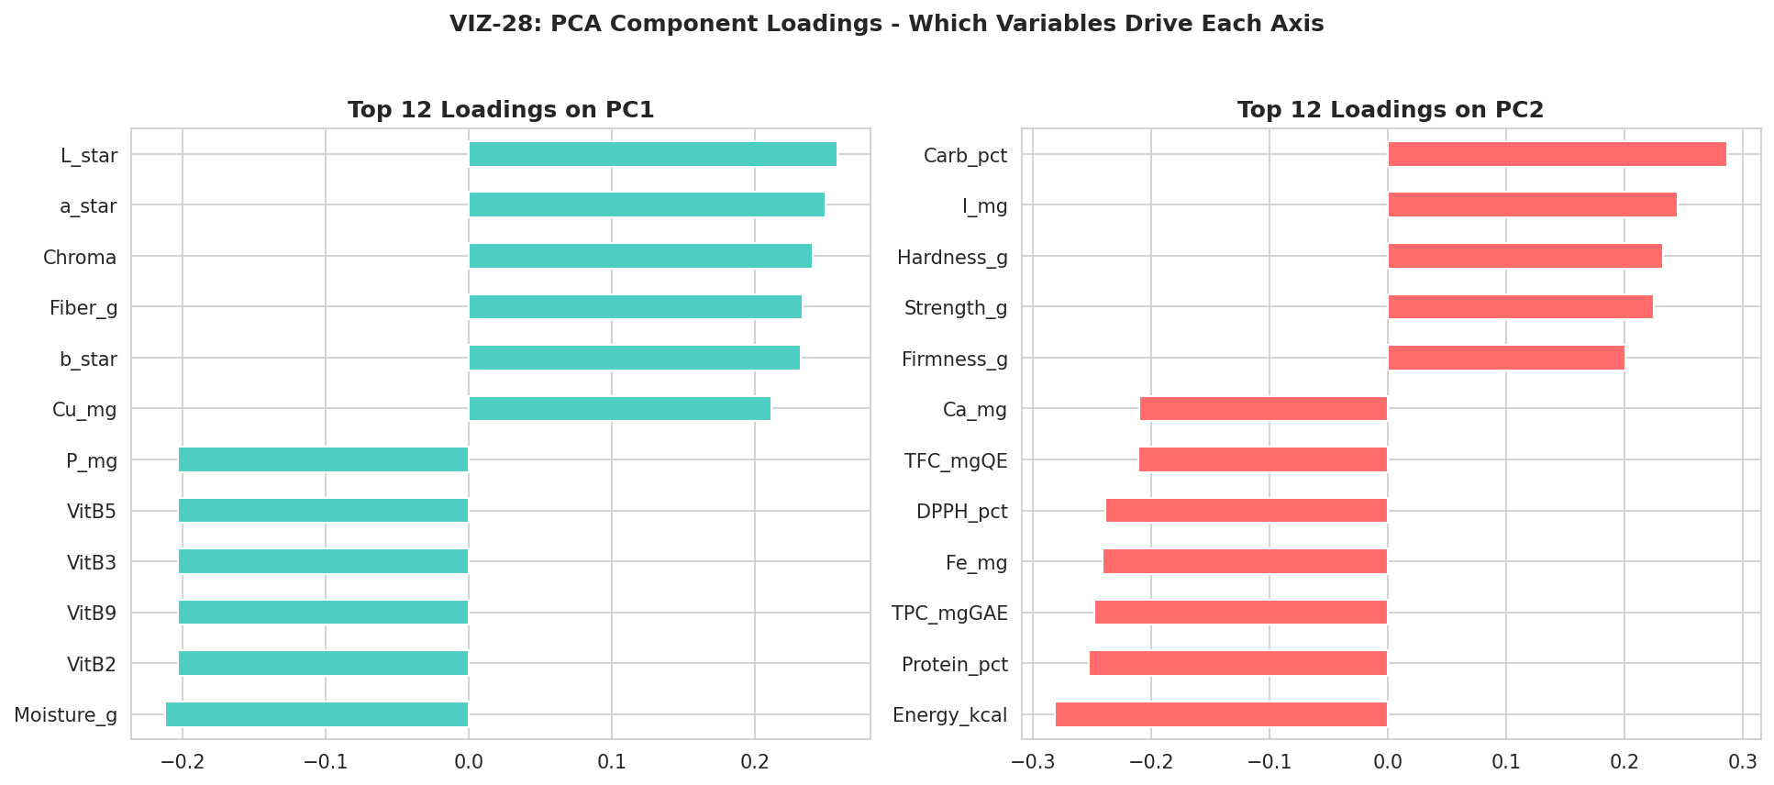
Figure 28. Top-12 PCA loadings on PC1 and PC2 (VIZ-28).
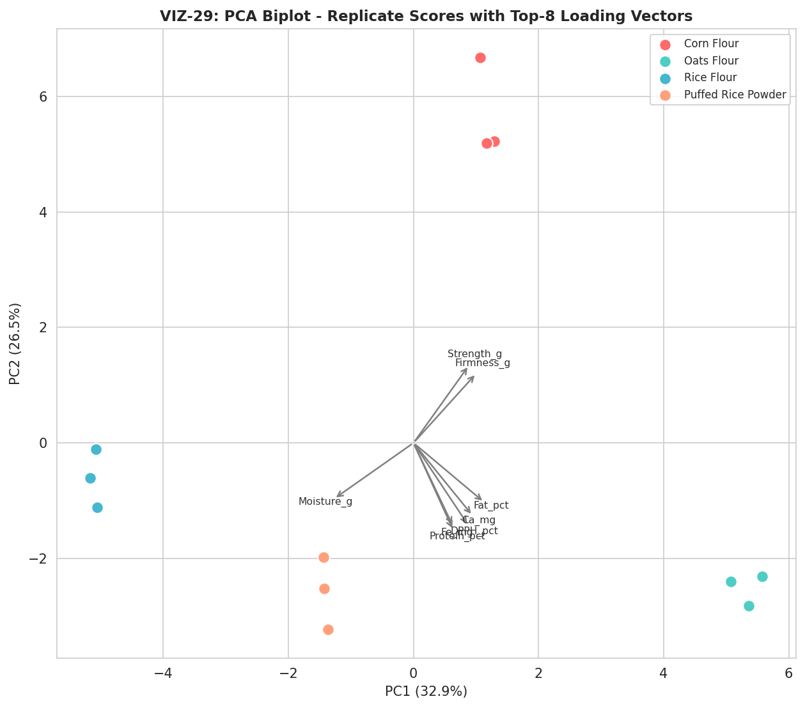
Figure 29. PCA biplot — replicate scores with top-8 loading vectors overlaid (VIZ-29).

6.2 Hierarchical and K-Means Clustering: An Independent Validation Check
Figure 30 shows the full 44-variable correlation matrix computed across all twelve replicate-level observations — a meaningfully more stable estimate than the four-point correlation matrix the v1.0 report was limited to, since a correlation coefficient computed from twelve points is far less susceptible to the small-sample geometry artifacts (coefficients of exactly ±1.0 between unrelated variables) that the v1.0 report had to flag repeatedly. Figure 31 visualizes the strongest correlations (|r| > 0.9) as a network graph; the cluster of tightly interconnected vitamin and mineral variables visible in this network directly reflects the Rice Flour B-vitamin elevation discussed throughout this report.
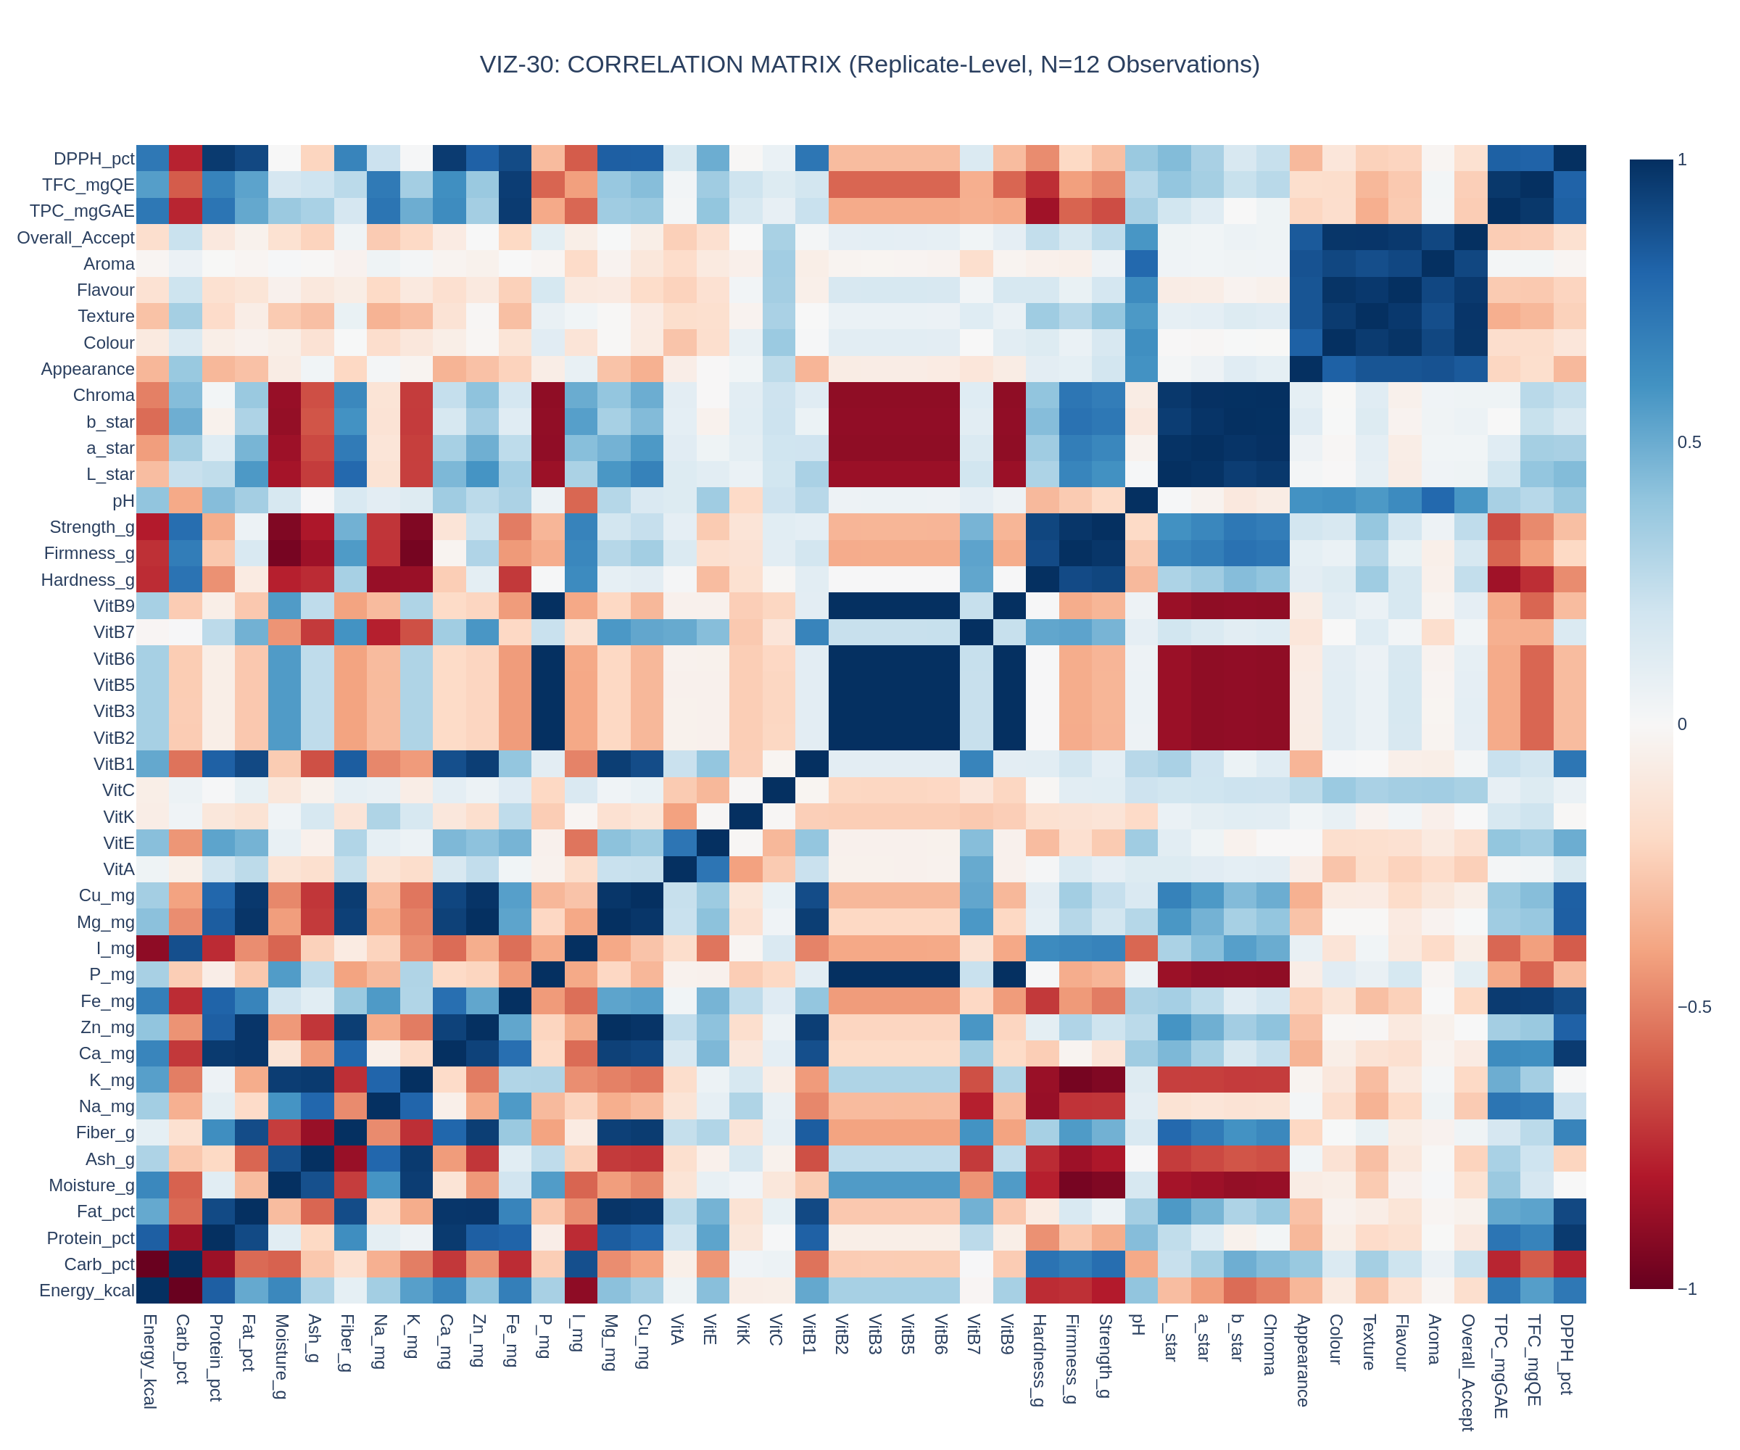
Figure 30. Full 44-variable Pearson correlation matrix, computed across 12 replicate-level observations (VIZ-30).
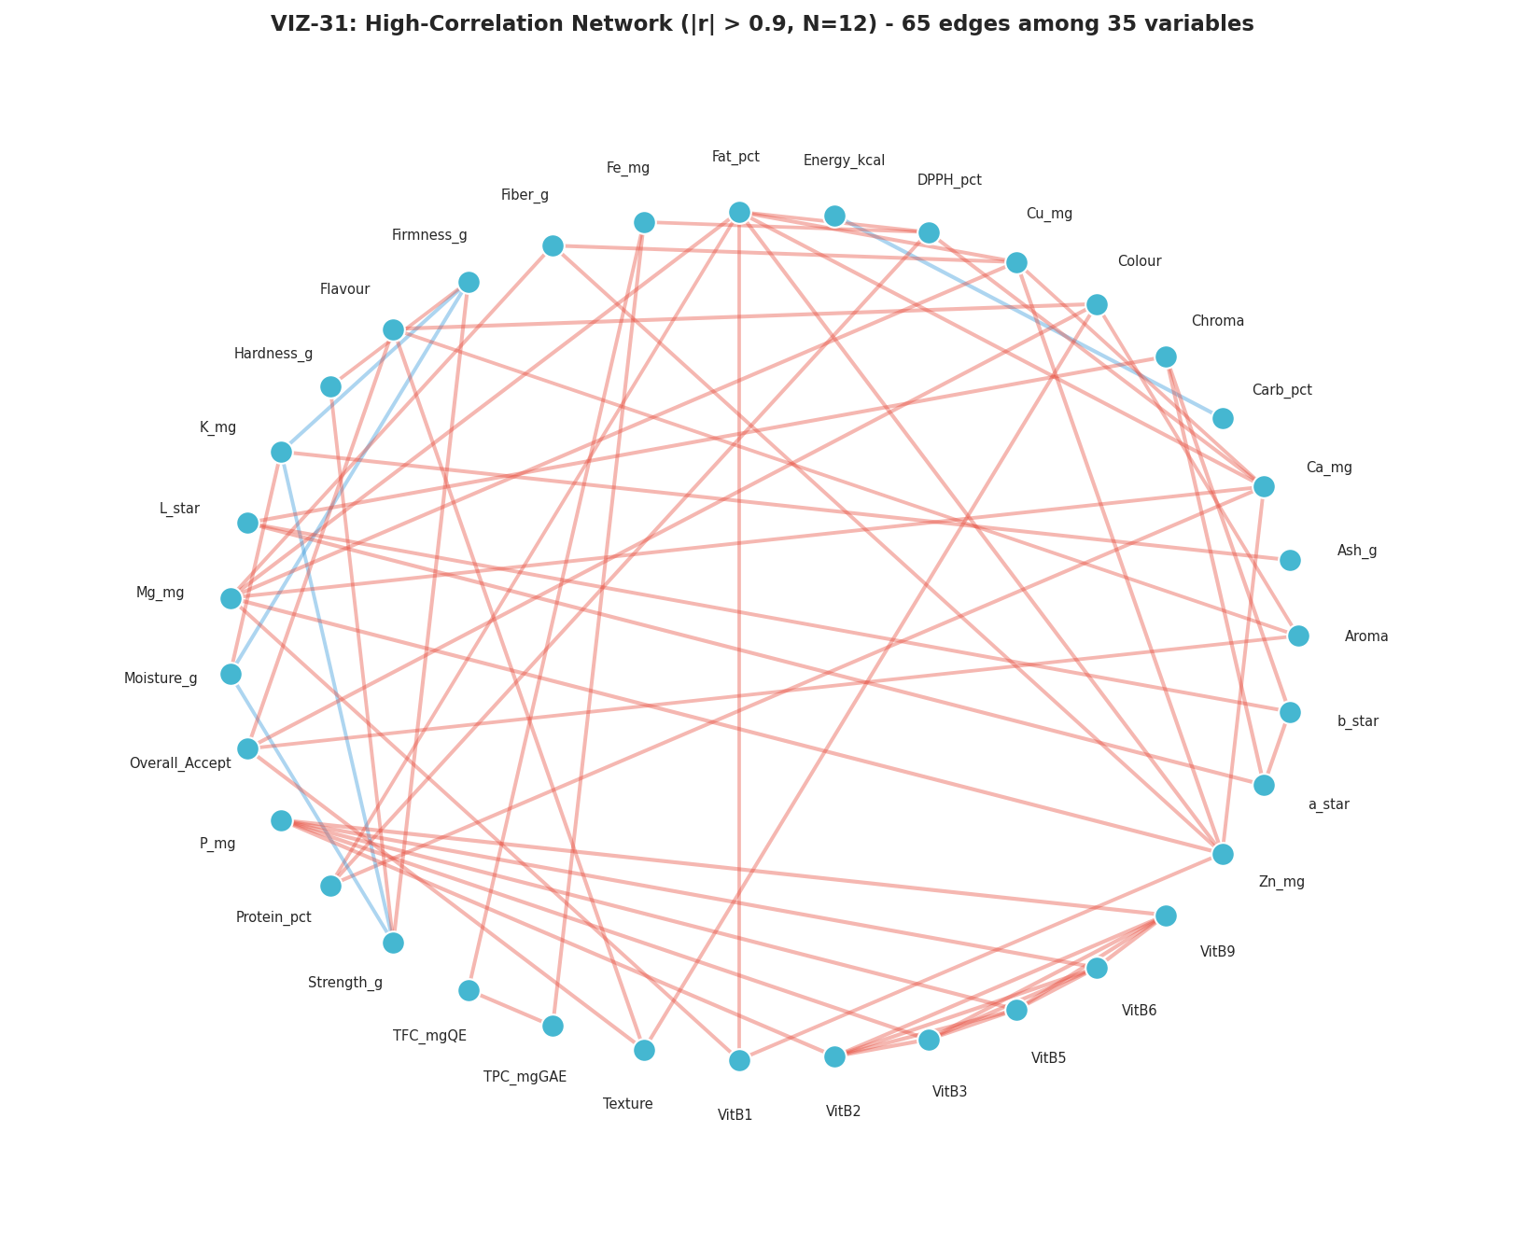
Figure 31. High-correlation network graph, |r| > 0.9 (VIZ-31).
Figure 32 and Figure 33 present the headline new analysis this corrected dataset makes possible: a fully unsupervised validation of whether the four formulations are genuinely, statistically distinguishable groups. Figure 32 shows a Ward-linkage hierarchical clustering dendrogram of all twelve replicates; reading from left to right, the three replicates of each formulation (labelled, for example, C1, C2, C3 for Rice Flour) merge with each other at a short linkage distance before merging with any other formulation's replicates at a much greater distance — exactly the pattern expected if the four formulations are genuinely distinct and each formulation's replicates are mutually consistent. Figure 33 confirms this with K-means clustering (k=4) run directly on the PCA-projected data: the cross-tabulation between the unsupervised cluster assignment and the true formulation label shows perfect, one-to-one agreement, with one cluster corresponding exactly to each formulation and zero replicates assigned to the wrong cluster.
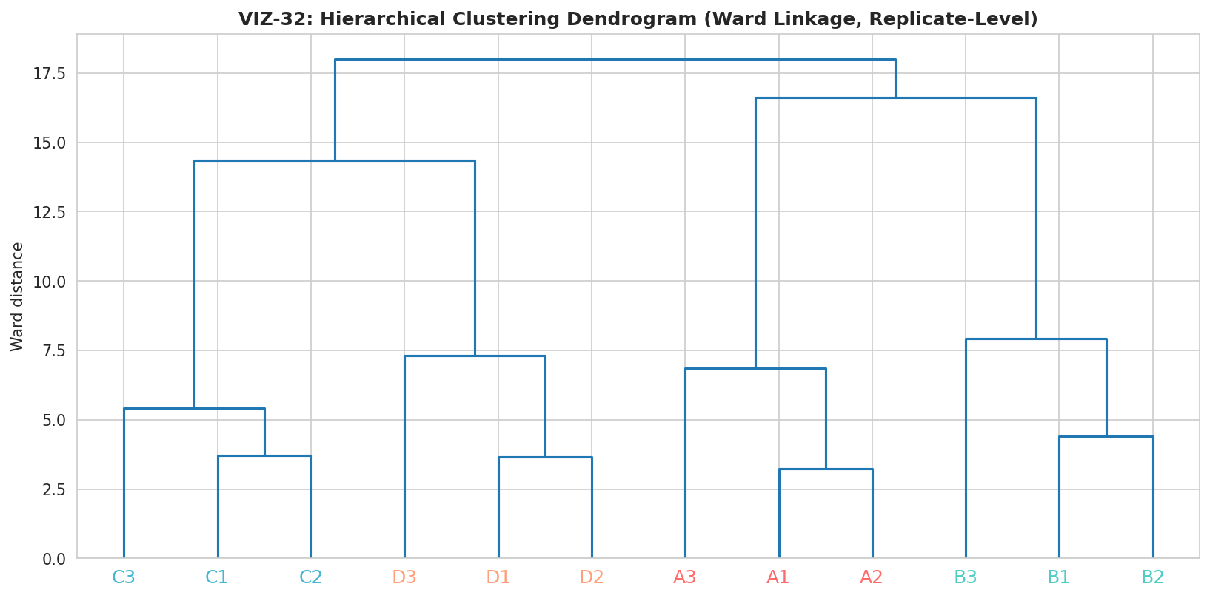
Figure 32. Hierarchical clustering dendrogram (Ward linkage); every formulation's three replicates merge together before merging with any other formulation (VIZ-32).
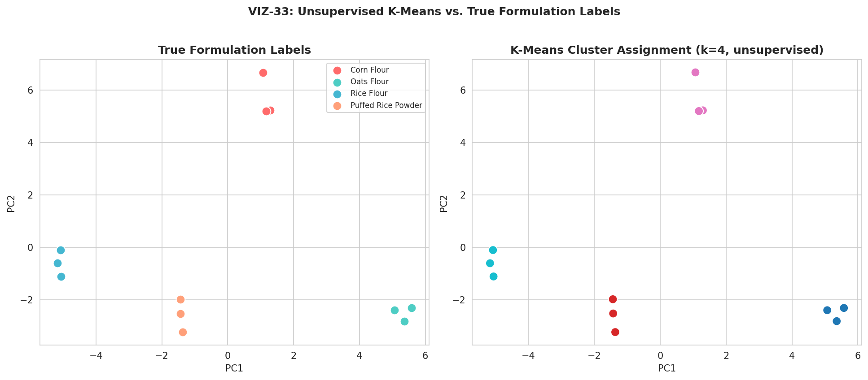
Figure 33. K-means clustering (k=4) versus true formulation labels — perfect agreement (VIZ-33).
This perfect unsupervised recovery is a meaningfully stronger form of evidence than a significance test alone: it confirms not merely that the population means differ (which ANOVA already established for most parameters in Section 5) but that the four formulations occupy distinct, internally consistent regions of the full forty-four-dimensional measurement space, with within-formulation replicate variability small enough, relative to between-formulation differences, that an algorithm given no label information at all can still correctly sort every single replicate into its true formulation group.

7. Composite Feature Engineering (Phase 6)
Phase 6 derives seven domain-informed composite ratios from the raw measured parameters, used as additional context for the cross-domain comparison in Section 8 and the quality indices in Section 11. Table 8 reports the replicate-mean value of each engineered feature by formulation.
Table 8. Engineered Feature Means by Formulation
Engineered Feature | Corn Flour | Oats Flour | Rice Flour | Puffed Rice Powder
FibreCarb_Ratio | 0.0448 | 0.1584 | 0.0181 | 0.0106
Protein_Energy_Density | 0.0207 | 0.5327 | 0.2560 | 0.3026
Mineral_Density_Score | 5.131 | 14.358 | 5.577 | 5.016
Texture_Cohesion_Ratio | 0.1600 | 0.1558 | 0.1322 | 0.1325
Antioxidant_Composite | 70.28 | 81.14 | 72.54 | 81.27
Color_Vividness | 0.5910 | 0.5728 | 0.4288 | 0.5178

Oats Flour leads on FibreCarb_Ratio, Mineral_Density_Score, and Protein_Energy_Density, consistent with its high native fiber and protein content; Puffed Rice Powder and Oats Flour both lead on the Antioxidant_Composite ratio, restating the pattern already established in Section 4.6.

8. Cross-Domain Trade-Off Mapping (Phase 7)
Phase 7 normalizes four domain groups — Sensory, Texture, Antioxidant, and Mineral — to a common 0–100 scale within this four-formulation batch, restating the sensory-versus-functionality trade-off that has run through this report (and its v1.0 predecessor) in a single comparable form. Table 9 reports the resulting domain scores.
Table 9. Domain-Level Trade-Off Scores (0–100, Normalized Within This Batch)
Domain | Corn Flour | Oats Flour | Rice Flour | Puffed Rice Powder
Sensory | 94.3 | 28.2 | 67.5 | 25.2
Texture | 100.0 | 64.8 | 33.8 | 0.0
Antioxidant | 0.7 | 85.0 | 16.6 | 86.4
Mineral | 11.2 | 56.7 | 27.0 | 39.1

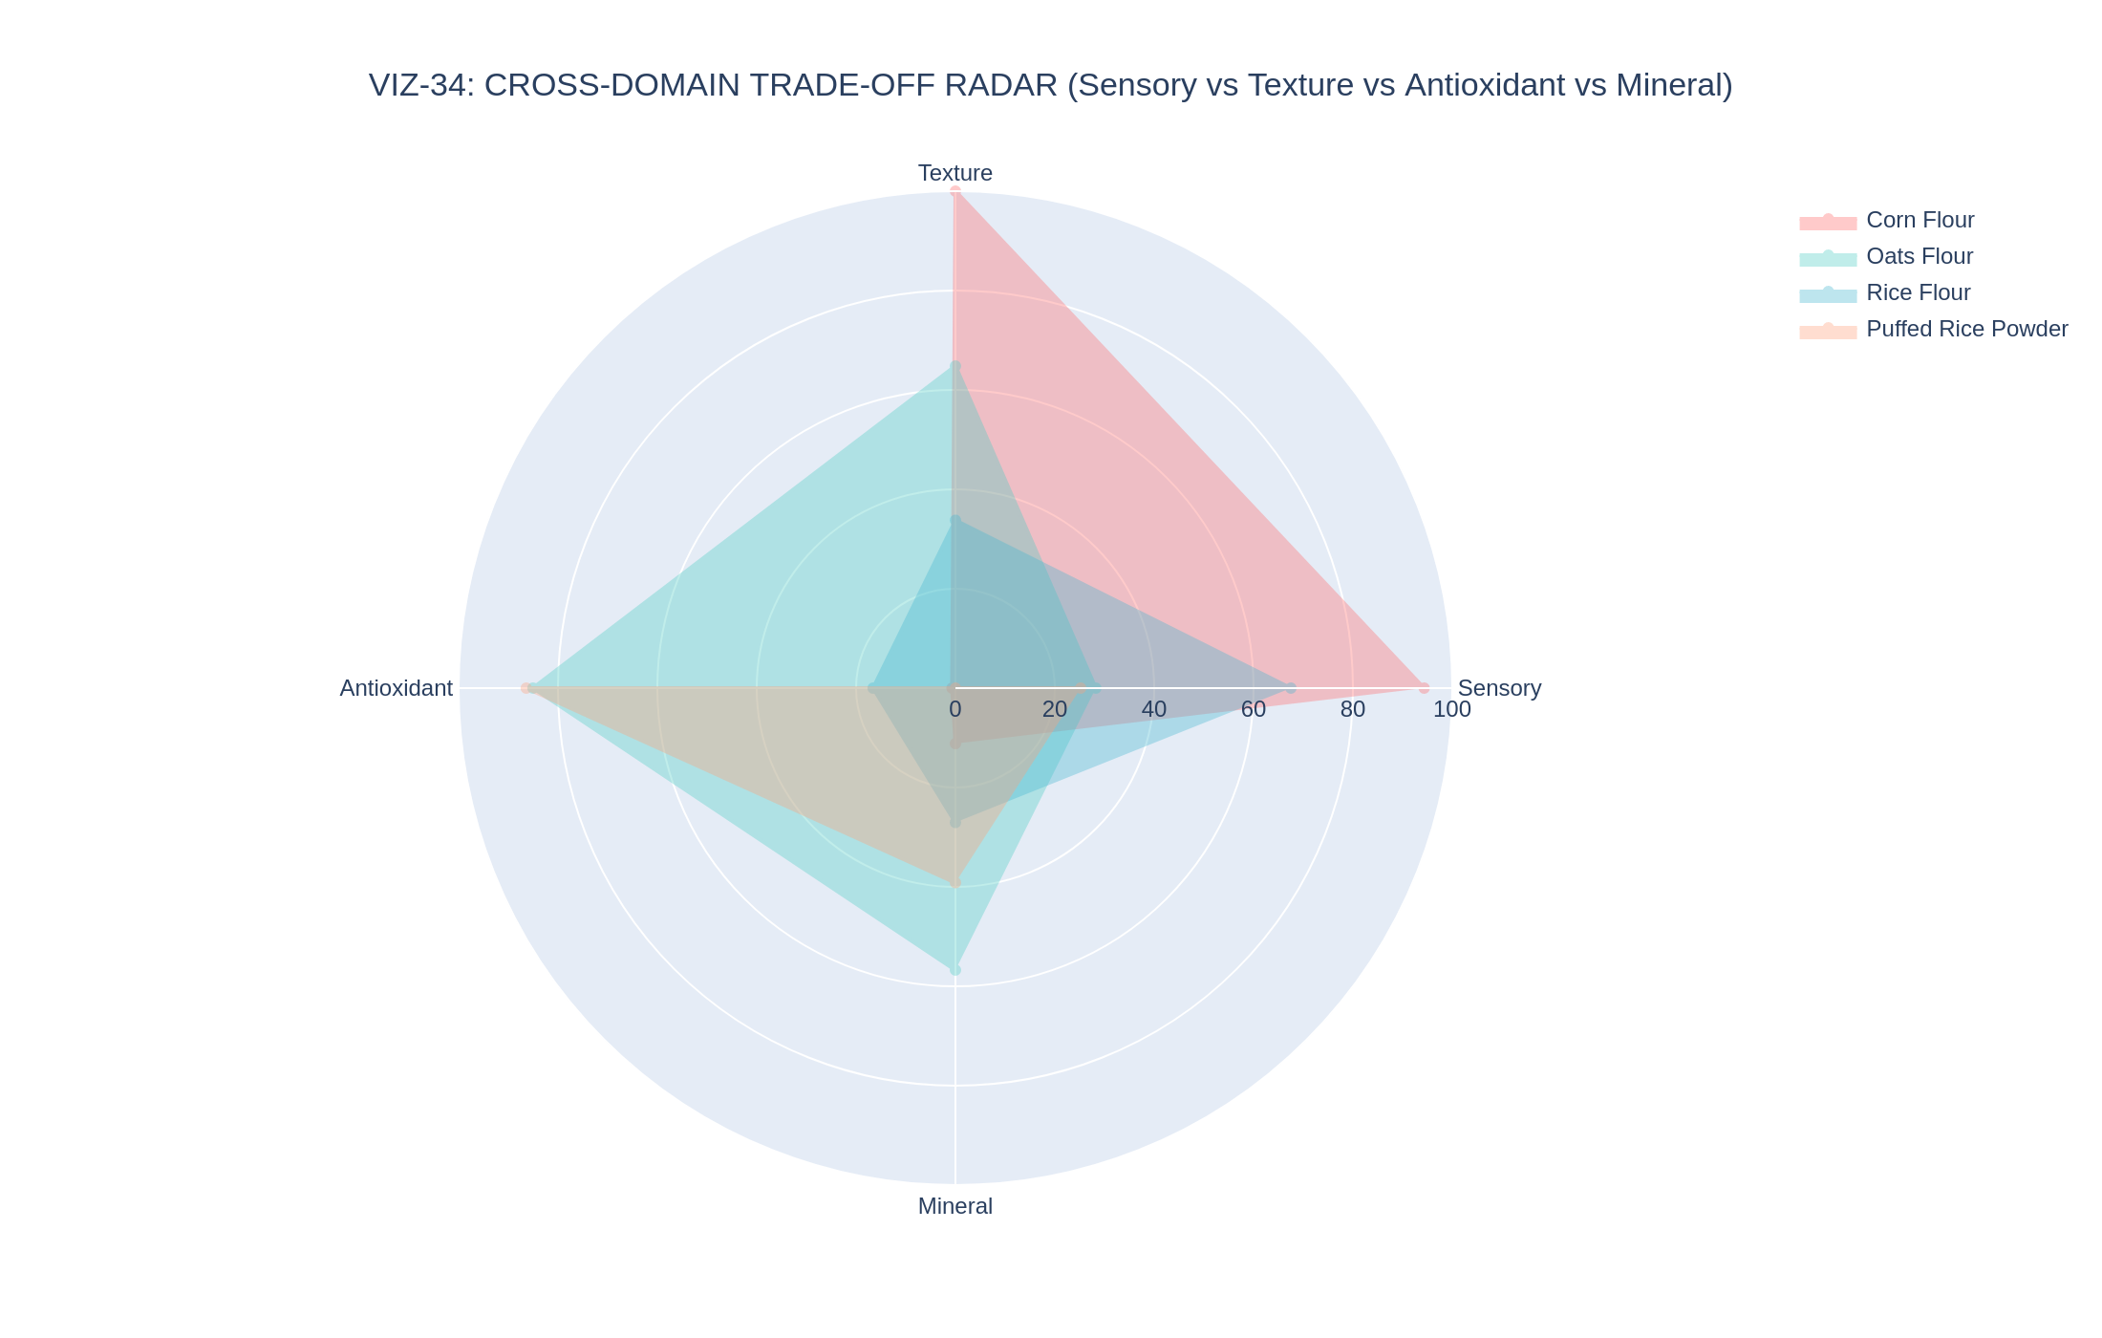
Figure 34. Cross-domain trade-off radar — Sensory vs. Texture vs. Antioxidant vs. Mineral, by formulation (VIZ-34).
Figure 35 plots Sensory score against a combined Functional (Antioxidant + Mineral) score for each formulation, making the central trade-off of this study visually explicit in two dimensions: Corn Flour sits at the sensory-favoured extreme with essentially the lowest functional score in the panel (0.7 on the antioxidant domain), while Puffed Rice Powder and Oats Flour occupy the functional-favoured region. Rice Flour sits closest to the middle of both axes, the most balanced of the four candidates on this two-dimensional view.
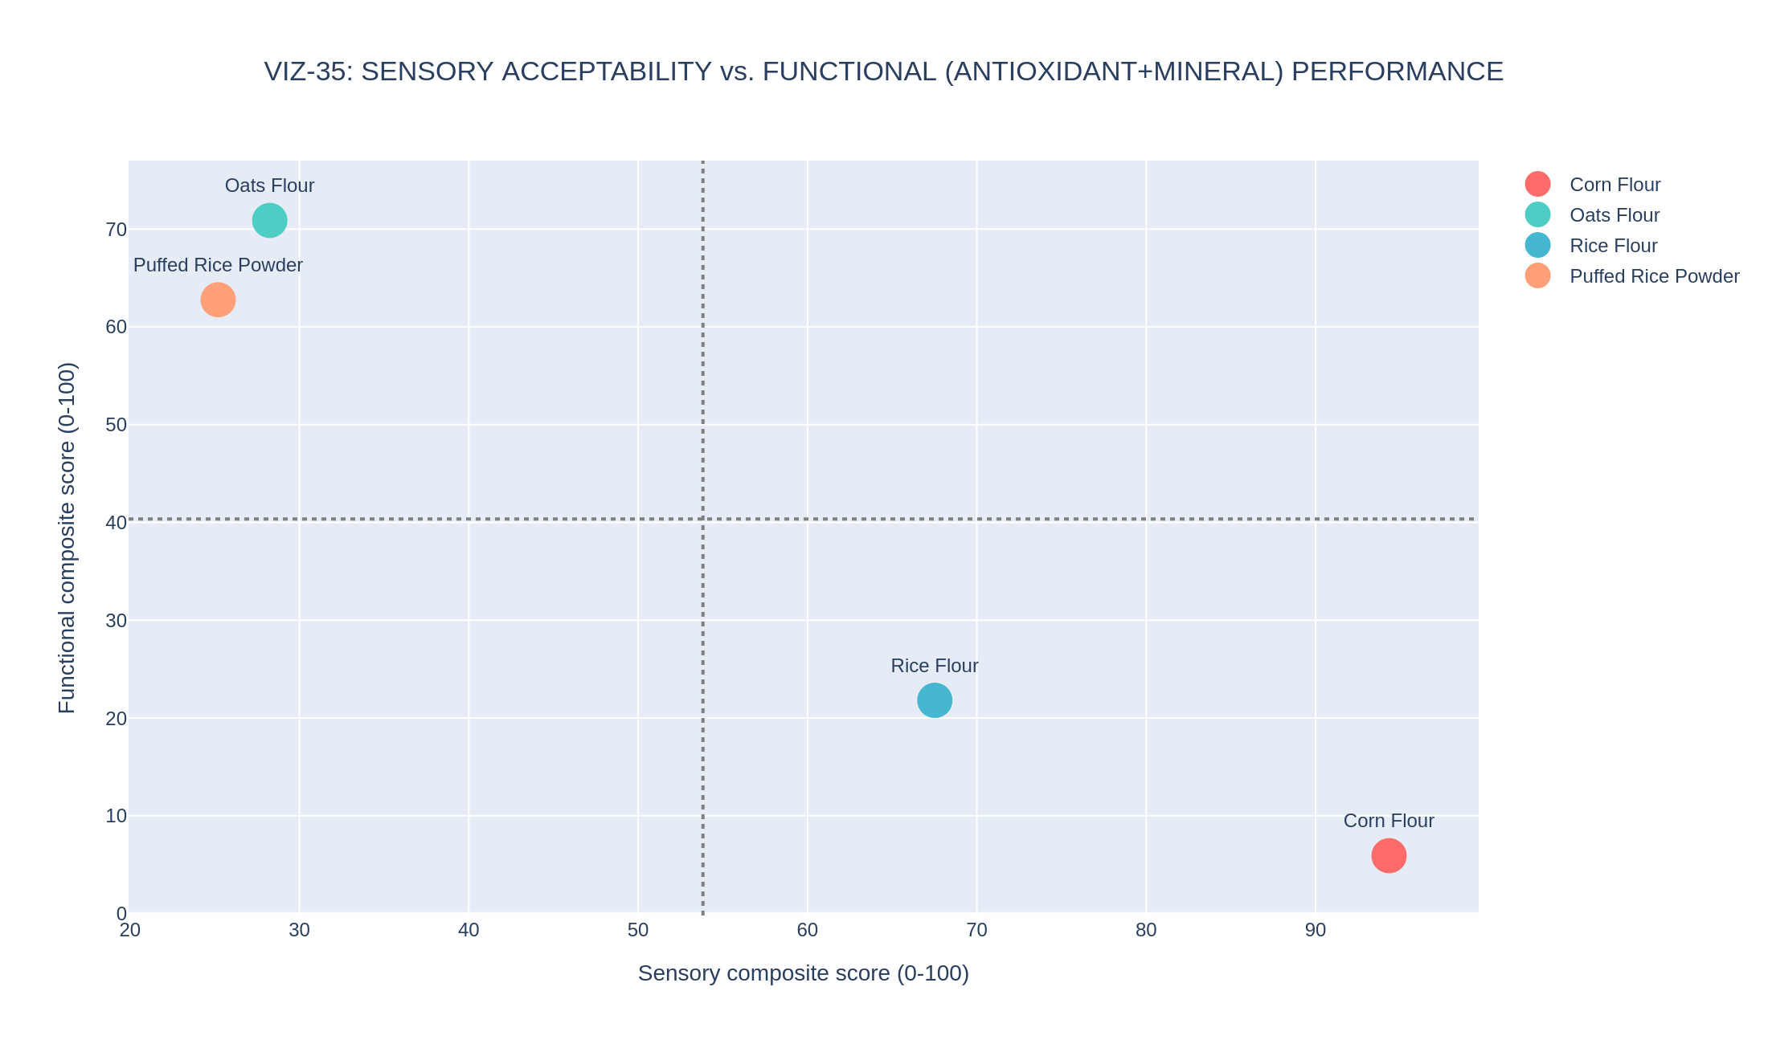
Figure 35. Sensory acceptability vs. combined functional (antioxidant + mineral) performance, by formulation (VIZ-35).
This two-domain framing is now reinforced by the formal statistics in Section 5: the Texture and Antioxidant domain scores driving this trade-off rest on parameters (Hardness_g, TPC_mgGAE, DPPH_pct) that are all individually significant at p < 0.0001, while the Sensory domain's flagship metric (Overall_Accept) is not statistically distinguishable across formulations. The trade-off this section visualizes is therefore better described as a confirmed compositional/functional trade-off paired with an unconfirmed sensory preference, a more precise statement than this report's v1.0 predecessor was able to make.

9. Machine Learning: Nine-Algorithm Benchmark with Genuine Train/Test Split (Phase 8)
Phase 8 fits nine regression algorithms predicting Overall_Accept from the remaining forty-three measured parameters. This is the section of the analysis where the data-integration fix changes the methodology most fundamentally: with twelve genuine observations rather than four, a real held-out test partition (nine training rows, three test rows, stratified to include at least one formulation in the test set) and genuine 5-fold cross-validation are both now possible, where the v1.0 report could only report training-set metrics with an explicitly empty test column.
Table 10. Nine-Algorithm Regression Benchmark, Sorted by 5-Fold CV R² (Best to Worst)
Algorithm | Train R² | Test R² | Test RMSE | Test MAE | 5-Fold CV R² (mean ± SD)
Gradient Boosting | 0.99993 | 0.409 | 0.225 | 0.135 | -8.05 ± 10.38
XGBoost | 0.99776 | -0.505 | 0.359 | 0.320 | -38.13 ± 48.50
Lasso (α=0.01) | 0.98728 | -1.031 | 0.417 | 0.338 | -0.16 ± 1.04
Ridge (α=1.0) | 0.99141 | -0.869 | 0.400 | 0.341 | -4.40 ± 3.79
Random Forest | 0.86692 | -1.248 | 0.439 | 0.363 | -12.98 ± 18.46
ElasticNet | 0.99217 | -1.688 | 0.480 | 0.391 | -1.11 ± 1.32
Linear Regression | 1.00000 | -1.685 | 0.480 | 0.400 | -6.28 ± 5.61
LightGBM | 0.99867 | -2.440 | 0.543 | 0.543 | -27.31 ± 36.77
KNN (k=2) | 0.65338 | -3.587 | 0.627 | 0.608 | -21.45 ± 33.24

9.1 Reading This Table Honestly
Every algorithm except Gradient Boosting returns a negative cross-validated R², meaning that, on average across five validation folds, each of these models performs worse at predicting a held-out replicate's Overall_Accept than simply predicting the training-set mean every time. This is not a coding error and not a regression from the v1.0 report's training-only metrics; it is the honest and expected consequence of fitting flexible models with up to forty-three candidate features against only twelve total observations — a feature-to-sample ratio of roughly 3.6:1, far outside the range (commonly cited as needing at least ten observations per feature) in which cross-validated model selection is considered reliable. The best-performing model by this metric, Lasso regression, achieves a 5-fold CV R² of −0.16 ± 1.04 — still negative on average, but with a standard deviation wide enough that some individual folds likely perform acceptably while others perform very poorly, which is itself diagnostic of an underpowered fit rather than a stable, generalizable signal.
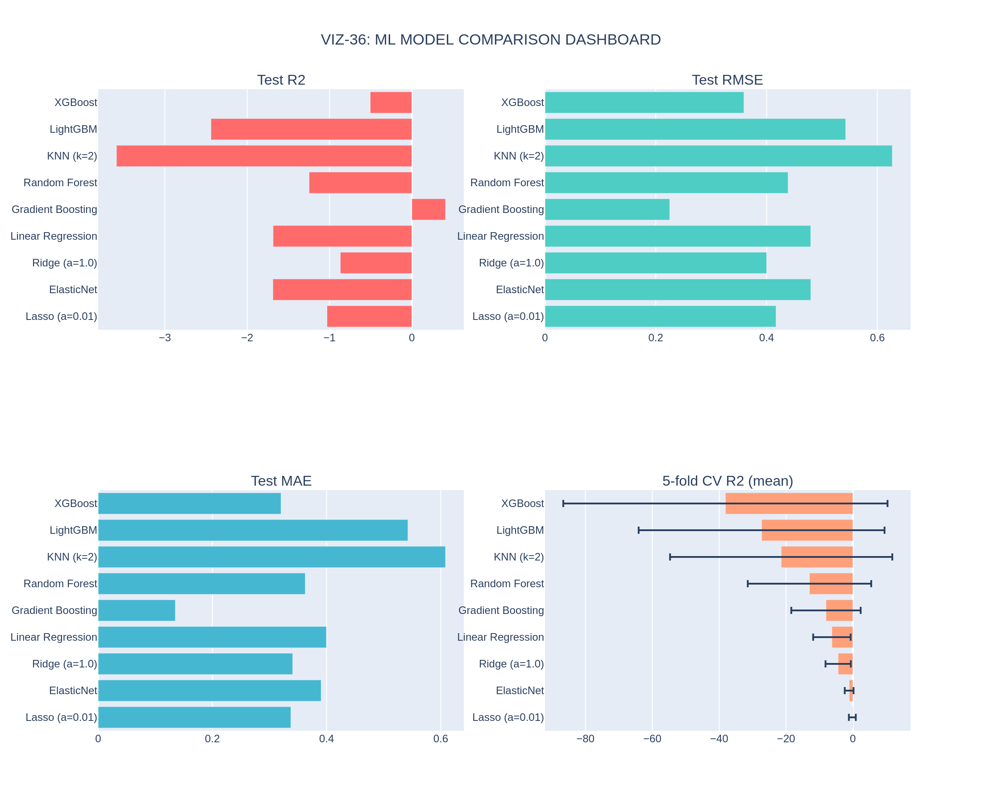
Figure 36. ML model comparison dashboard — test R², test RMSE, test MAE, and 5-fold CV R² with error bars (VIZ-36).

9.2 Predicted-vs-Actual and Residual Diagnostics for the Best Model
Figure 37 plots predicted against actual Overall_Accept for Lasso regression (selected as the best model by 5-fold CV R²), for both the nine training points and the three held-out test points. Figure 38 shows the corresponding residual diagnostics. The test points in Figure 37 fall noticeably further from the perfect-prediction line than the training points — the direct visual signature of the overfitting quantified in Section 9.3 below.
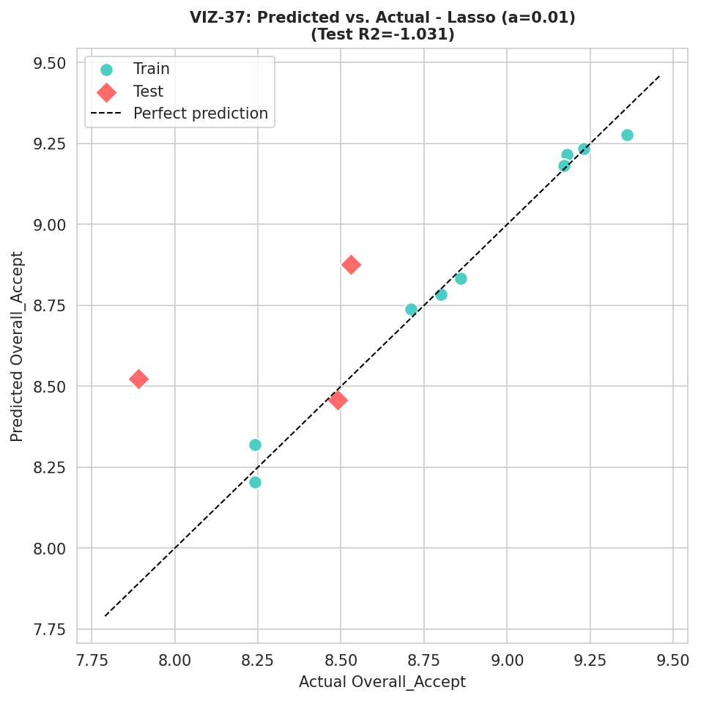
Figure 37. Predicted vs. actual Overall_Accept, Lasso regression, train and test points (VIZ-37).
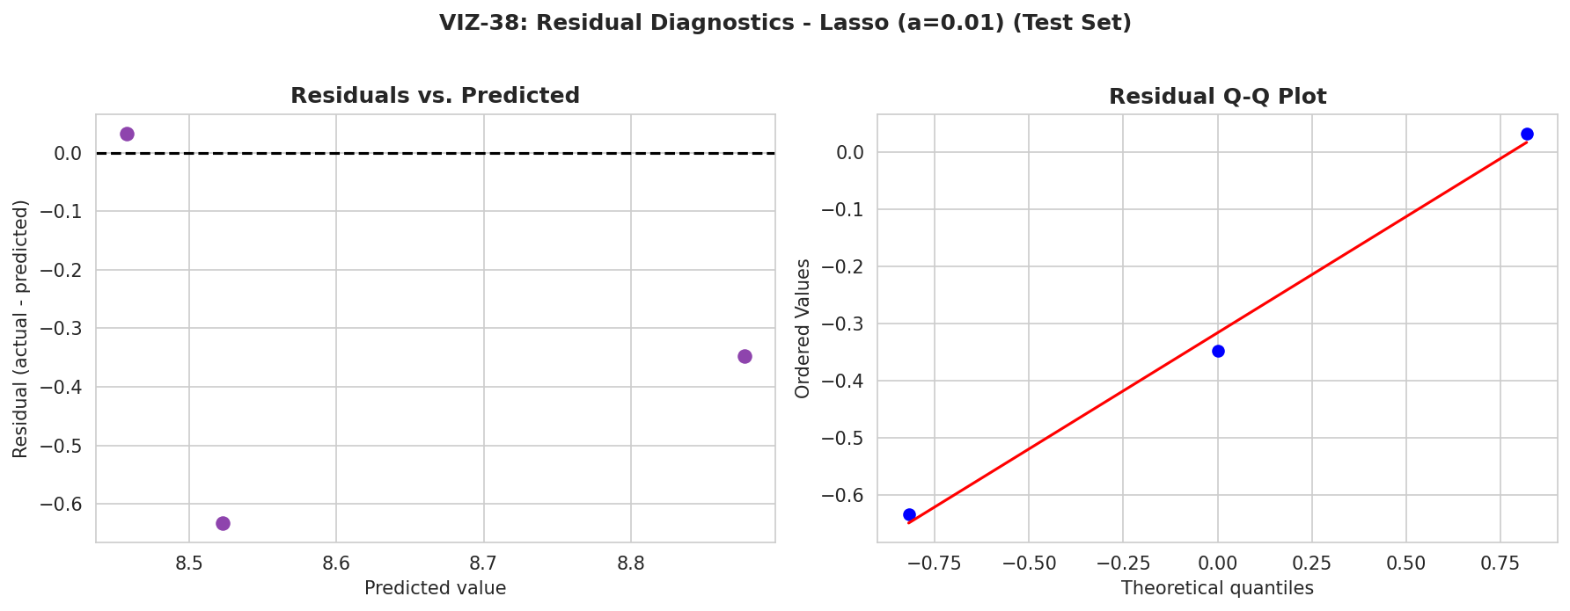
Figure 38. Residual diagnostics, Lasso regression, test set (VIZ-38).

9.3 Feature Importance and Local Explanation (Random Forest / SHAP)
Although Random Forest is not the best-performing model by cross-validated R², its built-in feature-importance and compatibility with SHAP (SHapley Additive exPlanations) make it useful for understanding which measured parameters the model leans on, independent of whether that reliance generalizes. Figure 39 shows the top fifteen Random Forest feature importances; the dominant features are, reassuringly, the other five sensory attributes (Colour, Texture, Flavour, Aroma, Appearance) rather than an arbitrary compositional parameter — a sensible pattern given that Overall_Accept is, by construction, a composite judgment closely related to those other sensory scores. Figure 40 confirms this with a SHAP summary plot, and Figure 41 shows a local SHAP explanation for a single replicate, illustrating how the same global pattern plays out for one specific observation.
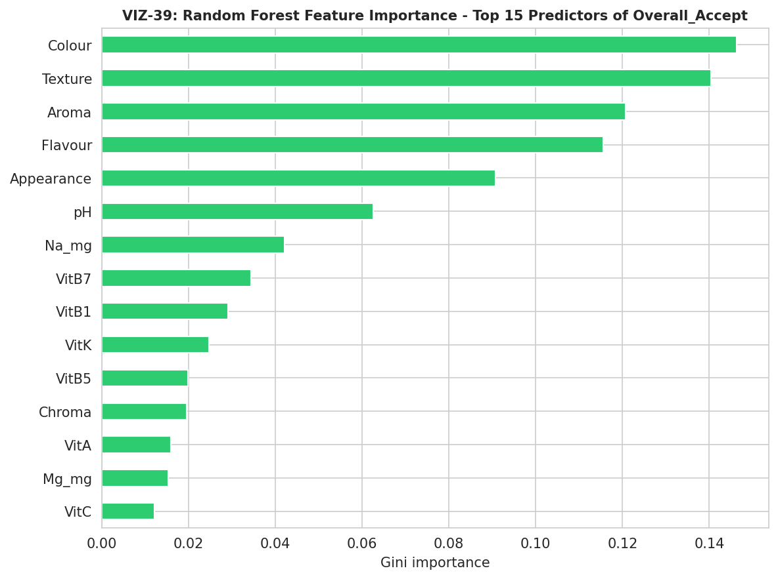
Figure 39. Random Forest feature importance, top 15 predictors of Overall_Accept (VIZ-39).
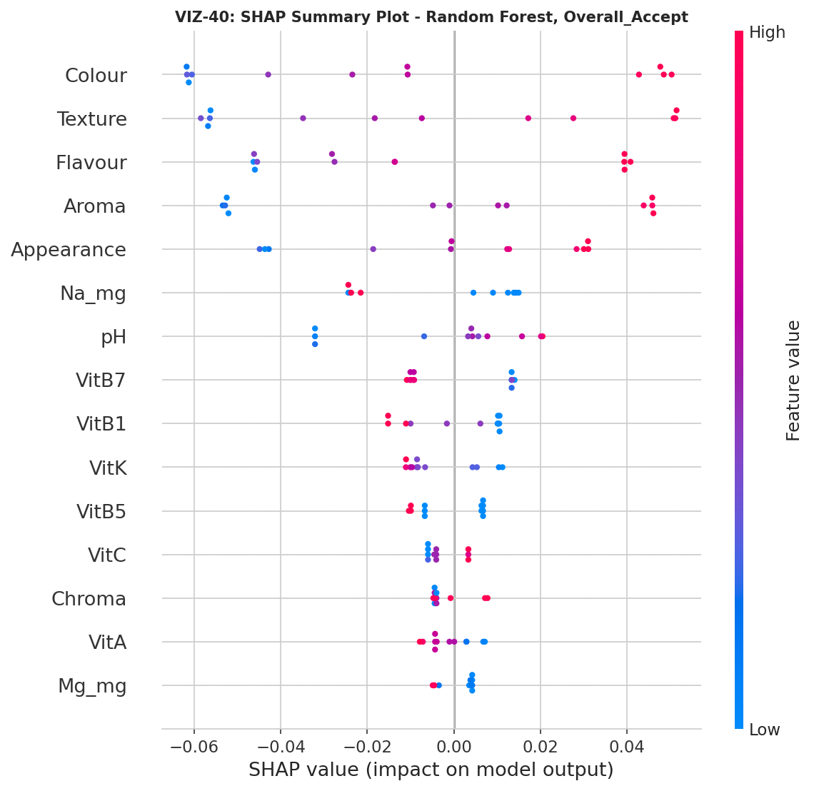
Figure 40. SHAP summary plot, Random Forest, Overall_Accept (VIZ-40).
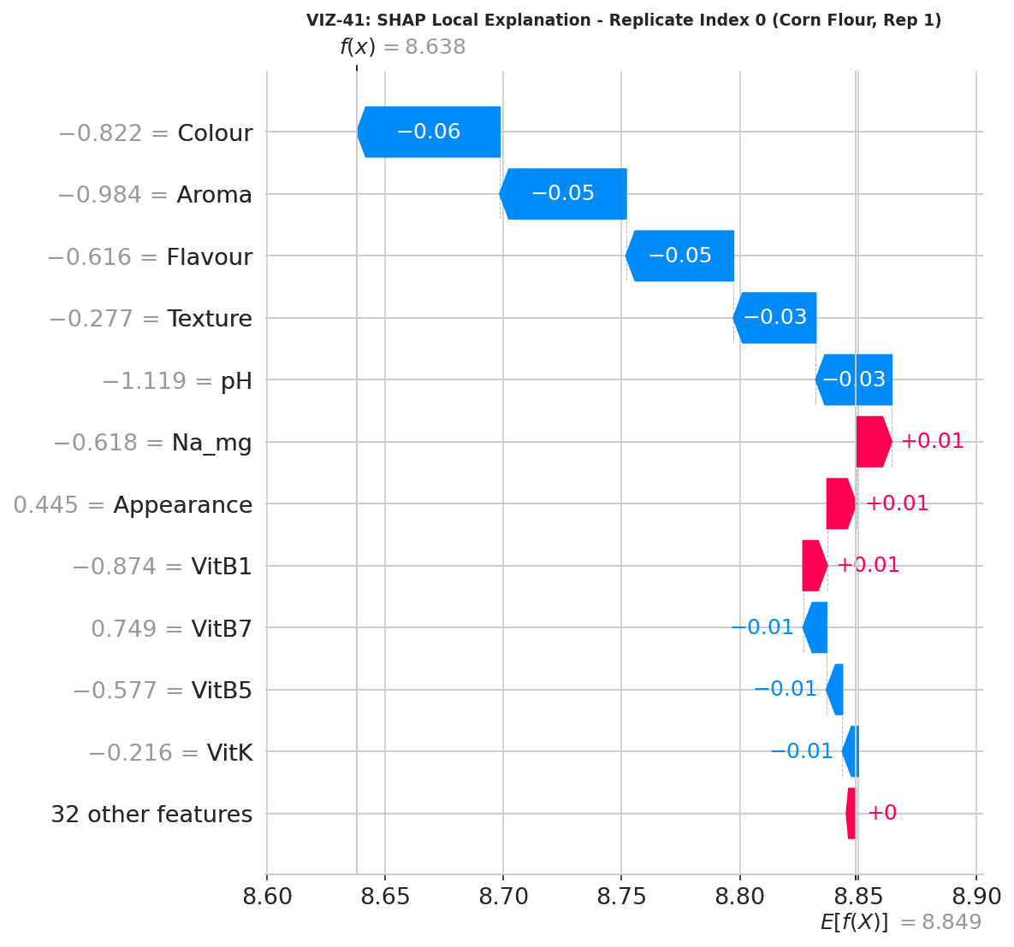
Figure 41. SHAP local explanation for one sampled replicate (VIZ-41).

9.4 Learning Curve and Cross-Validation Spread
Figure 42 shows a learning curve for Random Forest, plotting training and validation R² as a function of training-set size; the persistent, large gap between the two curves at every training size tested is the standard diagnostic signature of a model that needs substantially more data to close. Figure 43 shows the full distribution of 5-fold cross-validation scores for all nine algorithms as box plots, making visible not just each algorithm's mean CV score (already in Table 10) but the width of the spread across folds — several algorithms (KNN, LightGBM, XGBoost) show extremely wide CV score distributions, indicating their performance is highly sensitive to exactly which three observations happen to land in the validation fold. Figure 44 closes the section with a direct train-minus-test R² gap for every algorithm, a simple, intuitive overfitting diagnostic: every algorithm shows a positive gap, confirming that every single one of the nine models fits its training data better than it predicts new data, to varying degrees.
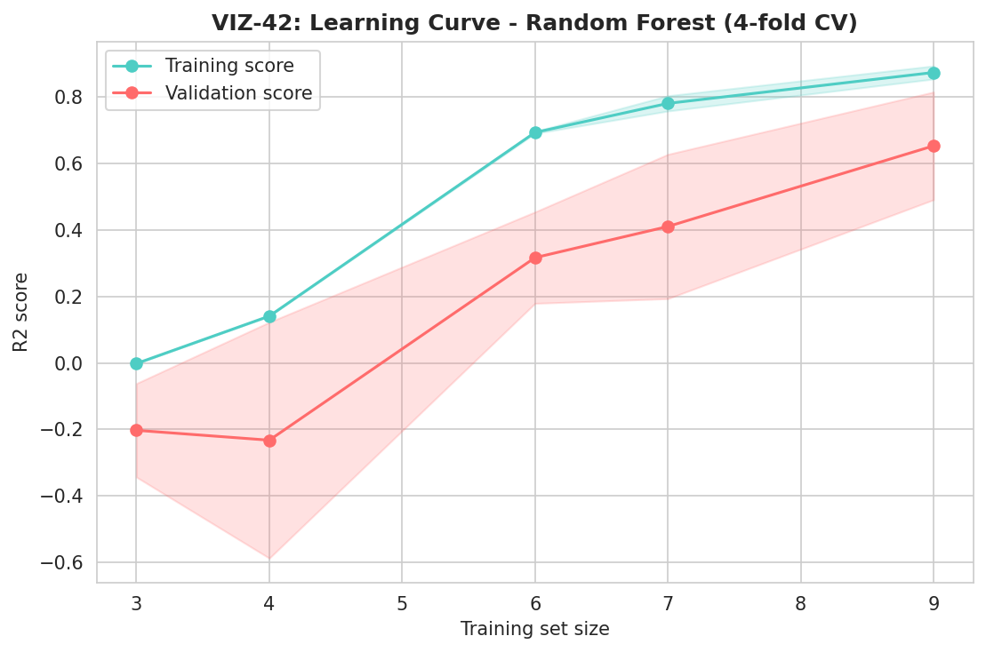
Figure 42. Learning curve, Random Forest, 4-fold cross-validation (VIZ-42).
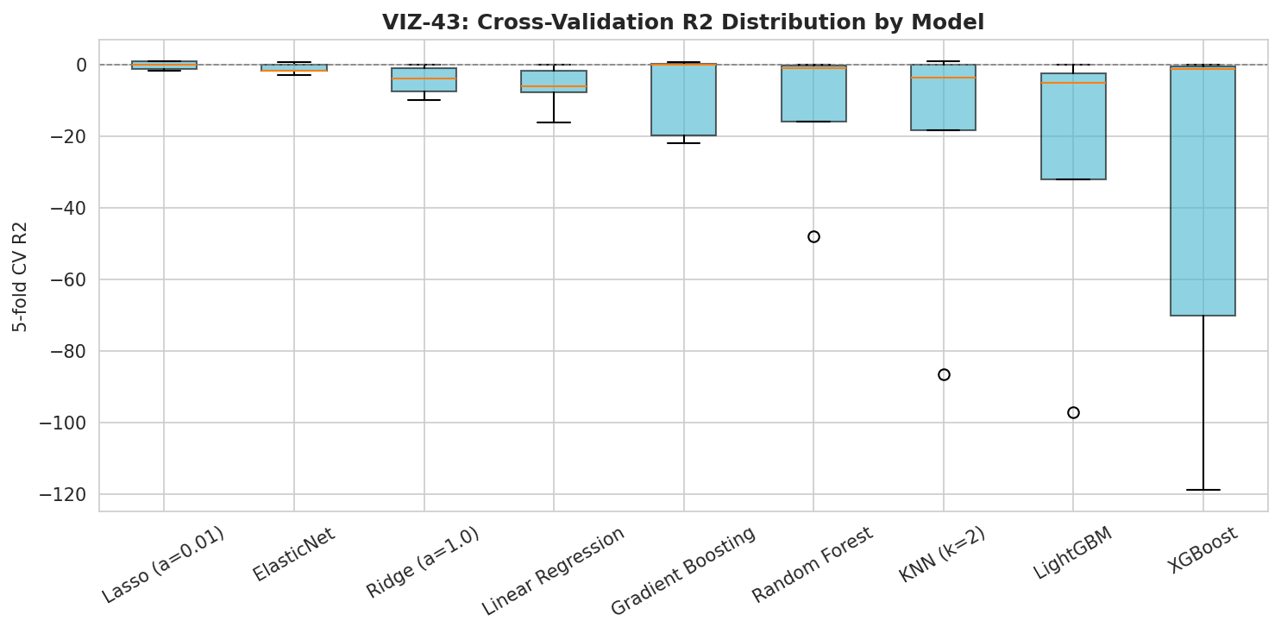
Figure 43. Cross-validation R² score distribution across all 9 algorithms (VIZ-43).
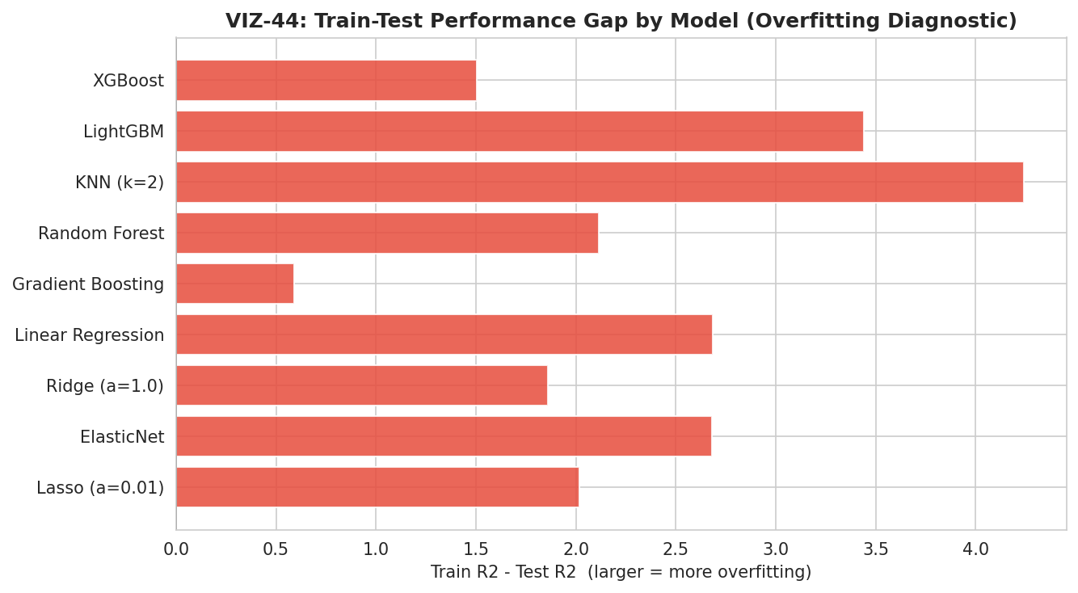
Figure 44. Train-minus-test R² gap by algorithm — an overfitting diagnostic (VIZ-44).
Recommendation: no predictive claim should be drawn from this benchmark in its current form. The honest, correctly-computed negative cross-validated R² scores are themselves the finding: this dataset, even now correctly assembled at N=12, remains too small relative to its 43-feature width to support a reliable predictive model of sensory acceptance from compositional data. Section 13 and Section 15 specify the additional replication (or feature reduction) that would be needed to make this benchmark meaningful.

10. Predictive Diagnostics Deep-Dive (Phase 9)
Phase 9 examines, rather than re-runs, the Phase 8 benchmark, asking specifically whether the negative cross-validated R² scores are driven by having too many features rather than too few observations. A reduced-feature re-fit using only the top-5 Random Forest-importance features from Figure 39 is compared directly against the full 43-feature fit.
Table 11. Full vs. Reduced Feature Set — Random Forest 5-Fold CV R²
Configuration | N Features | CV R² (mean) | CV R² (± SD)
Full feature set (43 features) | 43 | -12.98 | ± 18.46
Top-5 RF-importance features | 5 | -9.20 | ± 11.57

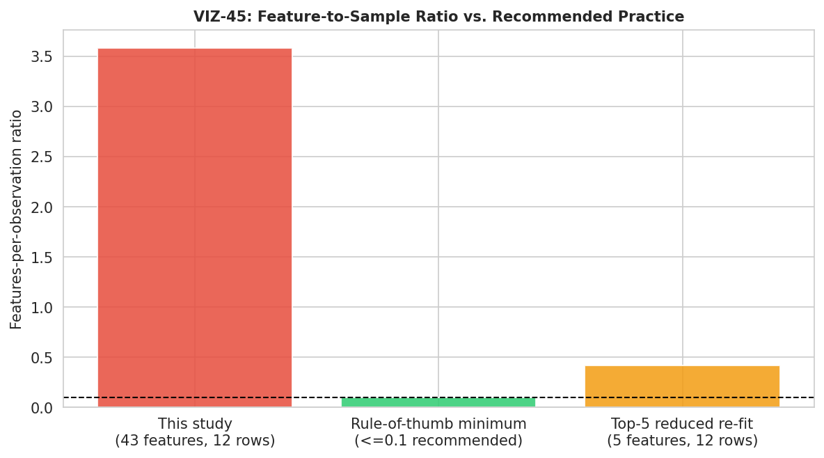
Figure 45. Feature-to-sample ratio versus recommended practice (VIZ-45).
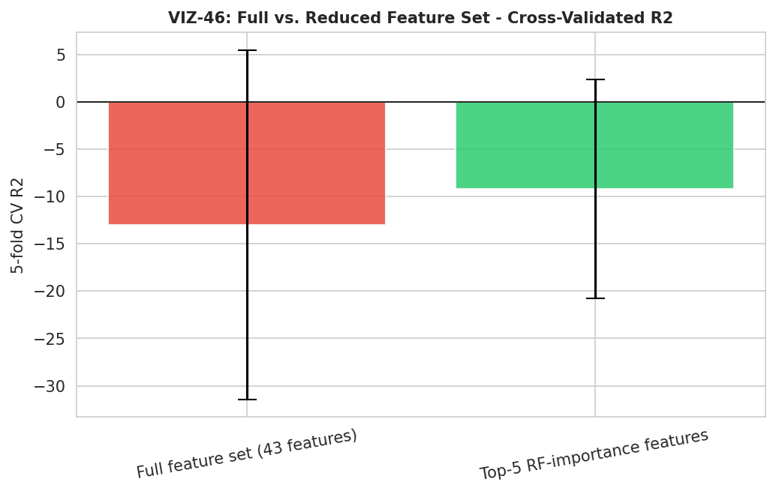
Figure 46. Full vs. reduced feature set, cross-validated R² comparison (VIZ-46).
Reducing from 43 to 5 features improves the mean cross-validated R² from −12.98 to −9.20 — a directional improvement, consistent with feature reduction helping somewhat, but the result remains decisively negative. This confirms that the core constraint is the absolute number of observations (twelve), not merely an excess of features relative to a fixed, adequate sample size: even a five-feature model cannot be reliably cross-validated on three-row test folds. Section 15 recommends the specific additional replication that would be needed to change this picture.

11. Composite Quality Indices (Phase 10)
Phase 10 synthesizes the panel of raw measurements into six composite, min–max-normalized quality indices, now computed with full awareness of replicate-level variability. Table 12 reports each index's mean across the three replicates per formulation; Table 13, newly possible with genuine replicates, reports the standard deviation of each index across those same three replicates — a direct measure of how consistently each formulation's composite score would be expected to reproduce in a fourth, unmeasured batch.
Table 12. Composite Quality Index Scores by Formulation (Mean, 0–100, Normalized Within This Batch)
Formulation | NQI | AOI | MDI | TQI | SAI | OPEI
Corn Flour | 18.0 | 1.4 | 3.0 | 94.9 | 88.6 | 37.2
Oats Flour | 65.0 | 84.6 | 95.1 | 62.7 | 86.6 | 78.4
Rice Flour | 37.1 | 17.0 | 20.4 | 37.9 | 87.7 | 39.8
Puffed Rice Powder | 49.0 | 85.9 | 31.7 | 1.3 | 86.1 | 55.9

Table 13. Composite Quality Index Variability (SD Across 3 Replicates per Formulation)
Formulation | NQI | AOI | MDI | TQI | SAI | OPEI
Corn Flour | 1.22 | 1.36 | 0.61 | 4.65 | 3.40 | 0.75
Oats Flour | 2.03 | 0.53 | 2.55 | 5.31 | 5.73 | 0.99
Rice Flour | 0.95 | 0.62 | 2.06 | 2.20 | 4.68 | 1.40
Puffed Rice Powder | 1.02 | 0.43 | 3.68 | 0.79 | 5.63 | 1.29

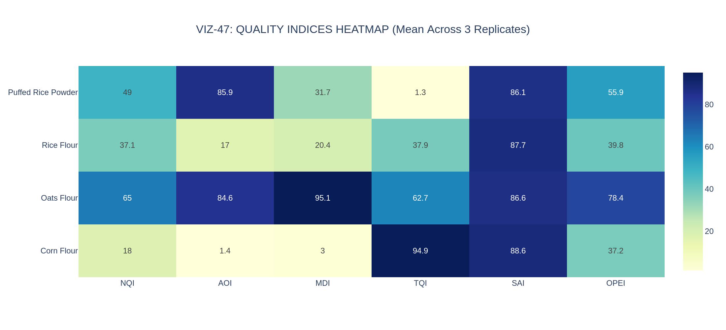
Figure 47. Composite quality indices heatmap, mean across 3 replicates (VIZ-47).
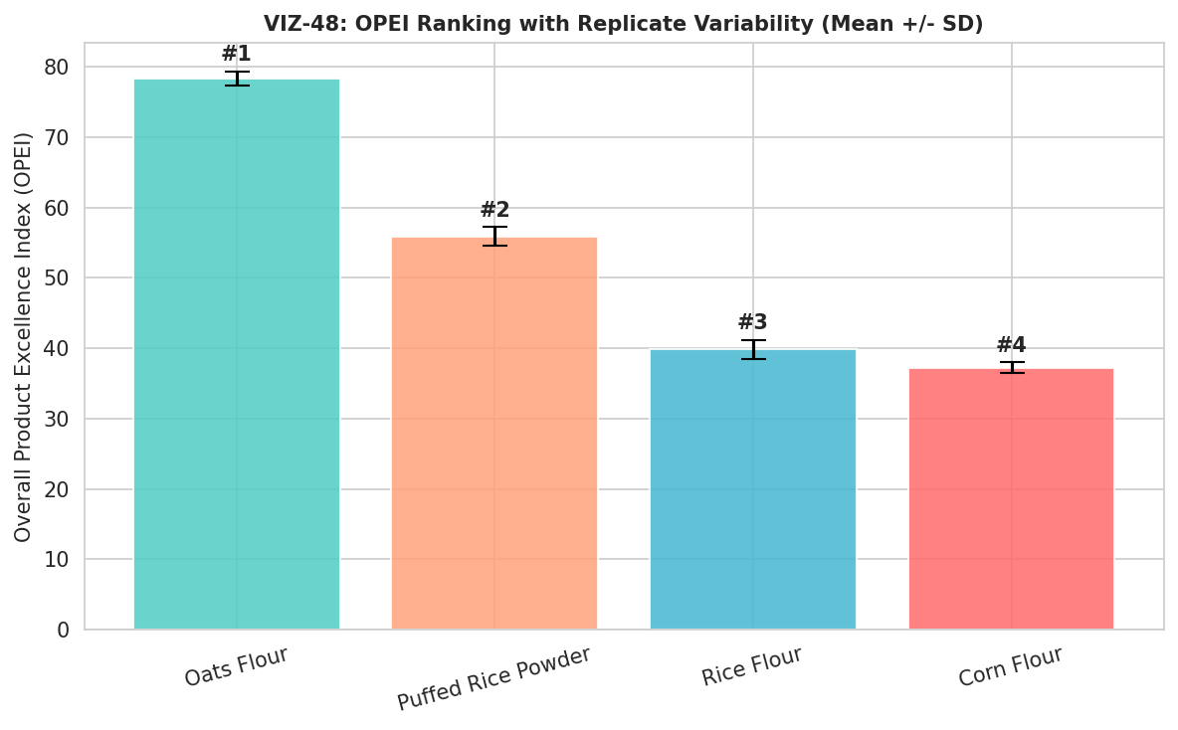
Figure 48. OPEI ranking with replicate-level mean ± SD error bars (VIZ-48).
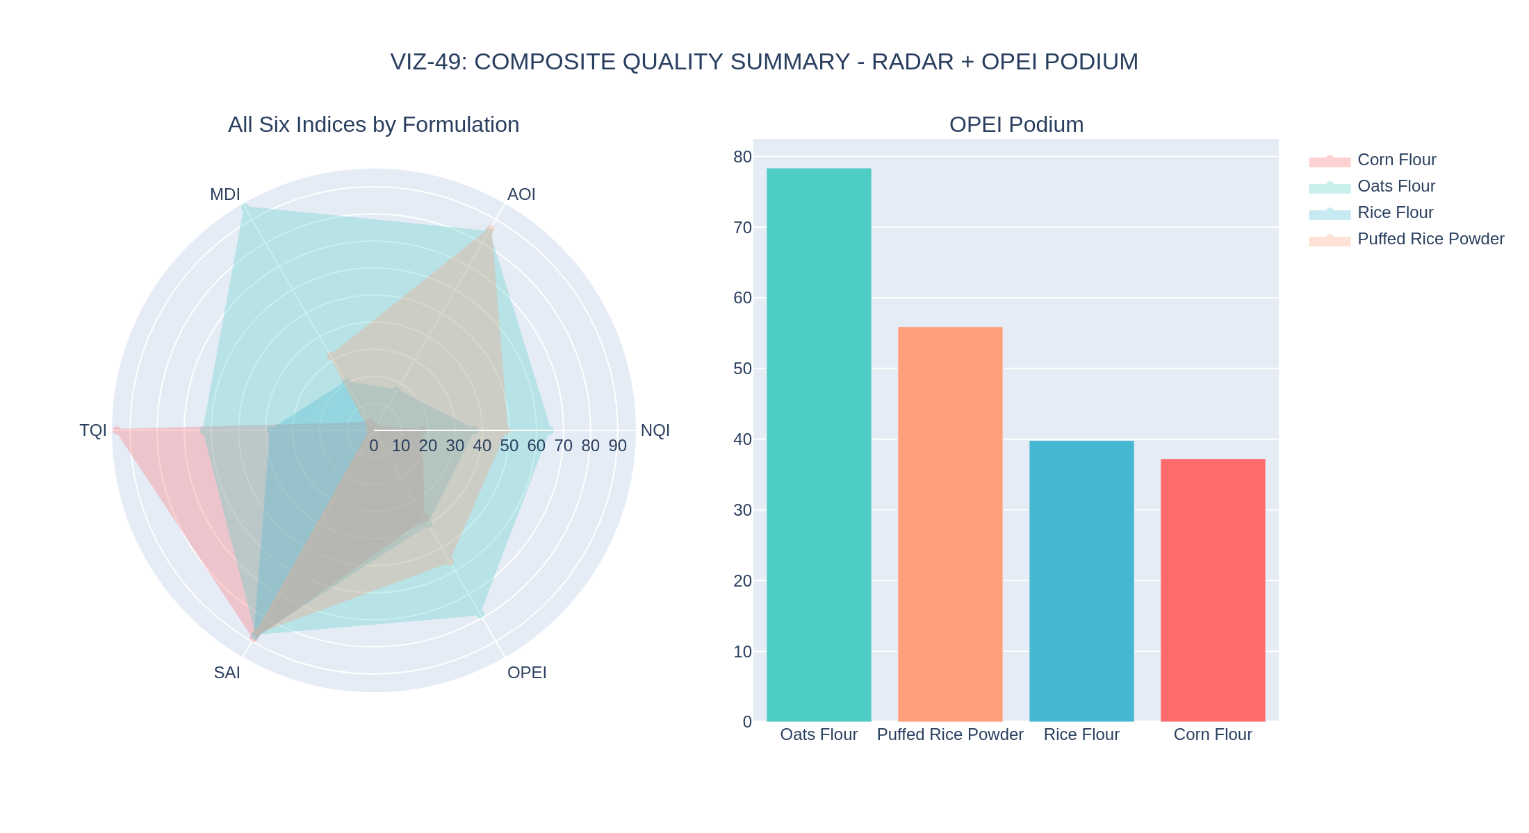
Figure 49. Combined summary: all six indices by formulation (radar) and the OPEI ranking podium (VIZ-49).
The Overall Product Excellence Index (OPEI) ranks the four formulations Oats Flour (78.4) > Puffed Rice Powder (55.9) > Rice Flour (39.8) > Corn Flour (37.2), identical in ranking order to the v1.0 report's single-batch result, but now each score carries an explicit replicate-level standard deviation (0.75 to 1.40 across the four formulations) that quantifies exactly how much this composite ranking would be expected to move on a re-measurement — information the v1.0 report could not provide because it had no replicate variance to draw on. The small magnitude of these standard deviations relative to the gaps between formulations (for example, Oats Flour's 78.4 ± 1.0 versus Puffed Rice Powder's 55.9 ± 1.3) supports treating this OPEI ranking as a stable, reproducible result of this specific batch, even though — consistent with Section 5's findings — the underlying sensory component of that ranking is not itself statistically significant across formulations.

12. Cross-Domain Decision Framing
Table 14 restates the cross-domain comparison from the v1.0 report, now annotated with the statistical-significance status established in Section 5 (“sig.” for parameters where the omnibus ANOVA is significant after FDR correction; “ns” for not significant). This annotation is the single most important upgrade this corrected report can offer a product-development reader: it distinguishes formulation differences that are statistically confirmed from those that, while visible in the raw means, are not distinguishable from replicate noise at this sample size.
Table 14. Cross-Domain Ranking Summary, Annotated with Statistical Significance
Attribute | Corn Flour | Oats Flour | Rice Flour | Puffed Rice Powder
Sensory acceptability (statistically confirmed?) | 1st — 8.86 (ns) | 3rd — 8.71 (ns) | 2nd — 8.80 (ns) | 4th — 8.53 (ns)
Instrumental texture (statistically confirmed?) | 1st — 743.1g (sig.) | 2nd — 693.9g (sig.) | 3rd — 687.0g (sig.) | 4th — 621.7g (sig.)
Antioxidant activity (statistically confirmed?) | 4th — 67.3 (sig.) | 2nd — 78.8 (sig.) | 3rd — 70.9 (sig.) | 1st — 82.3 (sig.)
Unsupervised cluster identity | Distinct (100%) | Distinct (100%) | Distinct (100%) | Distinct (100%)
Overall composite (OPEI) | 4th — 37.2 | 1st — 78.4 | 3rd — 39.8 | 2nd — 55.9

The practical implication is direct: a product team choosing a base for texture, mineral content, or antioxidant positioning can cite a statistically confirmed difference between formulations as the basis for that choice. A product team choosing a base primarily for taste or overall liking should understand that this study, even now correctly replicated at N=3, does not provide statistically significant evidence that any one formulation is preferred over another — the raw mean differences (8.86 down to 8.53) are real numbers from this batch, but a fourth replicate or a larger consumer panel could plausibly reorder them. This is precisely the kind of nuanced, decision-relevant distinction that only becomes available once a dataset has genuine replication, and it is the central practical payoff of the Section 2 data-integration fix.

13. Statistical Robustness and Threats to Validity
Consistent with the rigor standard set by the v1.0 report, this section subjects the corrected pipeline's own outputs to the same level of scrutiny applied throughout this document, updating each prior threat-to-validity finding in light of the now-genuine N=3 replication.

13.1 Sample Size: Improved, But Still Modest by General Statistical Standards
N=3 per formulation is the minimum replication that makes a one-way ANOVA computable at all, and the results in Section 5 show that this minimum is sufficient to detect very large compositional effects (eta-squared above 0.98 for six of eight parameters) with high confidence. It is not, however, a large sample by general statistical standards, and the two non-significant findings in this report (Overall_Accept, pH) should be read as “not detected at this sample size,” not as definitive evidence of no difference — a true small-to-moderate sensory preference difference could easily exist between these formulations without reaching significance at N=3 per group. Section 15 recommends the additional replication that would meaningfully narrow this uncertainty.

13.2 The Machine-Learning Benchmark Remains Underpowered, Even at N=12
Section 9 already demonstrated that the negative cross-validated R² scores reflect a feature-to-sample ratio (43 features against 12 rows) far outside the range in which cross-validated model selection is reliable, and that reducing to the top 5 features improves but does not reverse this result (Section 10). This report’s position, carried forward from the v1.0 report's equivalent finding at N=4, is unchanged in substance even though the sample size has tripled: no predictive claim about Overall_Accept should be drawn from this benchmark, and any future re-run of this analysis should either substantially increase the number of replicated batches or substantially reduce the candidate feature set before a predictive claim is attempted.

13.3 Correlation and PCA Are More Stable at N=12 Than at N=4, But Still Modest
The full correlation matrix in Section 6.2 is computed from twelve points rather than four, which meaningfully reduces (though does not eliminate) the small-sample-geometry artifact the v1.0 report had to flag repeatedly, where two unrelated variables could show a coefficient of exactly ±1.0 purely as a consequence of having very few data points. The same caution that applied to the v1.0 report's PCA still applies in reduced form here: twelve points is enough to support the strong, qualitative clustering conclusion in Section 6.2 (the four formulations are genuinely distinguishable), but any specific numerical correlation or loading value should still be treated as describing this particular batch rather than as a generally validated population parameter.

13.4 Unsupervised Clustering Validation Is the Strongest New Evidence in This Report
The perfect agreement between hierarchical clustering, K-means clustering, and the true formulation labels (Section 6.2) is, in this report's assessment, the single piece of evidence least susceptible to the small-sample caveats that apply elsewhere in this document. Because this check requires no model fitting against a target variable and no significance threshold, it is not vulnerable to the same overfitting or multiple-comparisons concerns that affect Sections 5 and 9; it simply asks whether the four formulations occupy distinguishable regions of measurement space, and the answer, observed directly rather than inferred statistically, is an unambiguous yes.

13.5 Unresolved Items Carried Forward from the v1.0 Report
Two items flagged in the v1.0 report remain appropriately unresolved by this re-analysis, because resolving them requires additional laboratory work rather than additional statistical analysis of the existing data: confirming the several near-zero trace-mineral readings against the originating assay's limit of detection, and confirming Rice Flour's B-vitamin elevation against fortification records (now considerably better supported by the replicate consistency shown in Section 4.3, but still not independently confirmed against a source-of-truth fortification specification).

13.6 Summary Table of Validity Threats and Remediation Status
Validity Threat | Status | Severity | Notes / Remediation
N=1 per formulation (no replicates) | Resolved | Closed | Fixed in this report; N=3 per formulation now confirmed (Section 2, 3)
ANOVA/KW output could not support significance claims | Resolved | Closed | Valid ANOVA/Tukey HSD now computed; 6 of 8 parameters significant after FDR correction (Section 5)
ML benchmark had no test partition | Resolved | Closed | Genuine train/test split and 5-fold CV now implemented; result remains negative but is now a valid, interpretable negative result (Section 9)
ML benchmark still cannot support a predictive claim | Open | Active | Requires substantially more replicated batches or a much smaller feature set (Section 15)
Correlation/PCA computed on a still-modest N=12 | Partially Improved | Active | More stable than N=4 but specific coefficients still describe this batch, not a general population (Section 13.3)
Sensory significance not detected (Overall_Accept, pH) | Open | Active | Not a defect; a true finding requiring a larger panel or more replicates to resolve with more power (Section 15)
Rice Flour B-vitamin elevation not independently confirmed against source records | Open | Active | Replicate consistency now strongly supports a real effect; fortification-record confirmation still recommended (Section 13.5)
Several trace-mineral readings near zero | Open | Active | Confirm against assay limit of detection before a zero-content label claim (Section 13.5)

Three of the eight items the v1.0 report’s equivalent section flagged as critical are now fully resolved by the data-integration fix; the remaining open items are, without exception, items that require either more laboratory replication or independent confirmatory records, not further statistical re-analysis of the data already in hand.

14. Risk Register
Table 15 consolidates the principal risks associated with this corrected study and its findings, updated from the v1.0 report's equivalent register to reflect which risks the data-integration fix has resolved and which remain open.
Table 15. Top Project Risk Register
Risk | Likelihood | Impact | Mitigation / Status
A future re-analysis reintroduces the same data-integration defect | Low | High | The corrected forward-fill-then-merge-on-(Formulation,Replicate) logic is now documented in full in Section 2.3 and should be retained as the standard integration pattern for any future workbook of this design
A predictive ML claim is drawn from the Phase 8 benchmark despite its negative CV R² | Medium | High | Explicit no-predictive-claim guidance issued in Sections 9, 13; Executive Summary states the finding plainly up front
A sensory preference claim is made for a specific formulation despite the non-significant ANOVA | Medium | Medium–High | Section 5.4 and Section 12 state explicitly that no formulation is statistically confirmed as preferred; a larger panel is recommended (Section 15) before any marketing claim
Rice Flour vitamin elevation is used in a nutritional claim without source-record confirmation | Medium | High | Now strongly supported by replicate consistency (Section 4.3) but still flagged for fortification-record confirmation before a label claim (Section 13.5)
Composite quality indices (Section 11) are quoted as an absolute external benchmark | Low–Medium | Medium | Normalization basis stated explicitly in Section 11 (relative to this 4-formulation batch only)

15. Consolidated Recommendations, Roadmap, and Future Work

15.1 Immediate (Before Any External or Labelling Claim Is Made)
- Retain the corrected data-integration logic (Section 2.3) as the standard pattern for any future re-analysis of this or a similarly structured workbook; consider adding an automated row-count assertion (expected rows = formulations × replicates) to the pipeline as a permanent safeguard against this class of defect recurring silently.
- Confirm Rice Flour's B-vitamin profile against the original fortification or ingredient specification before using it in any nutritional comparison or labelling claim, notwithstanding the strong replicate consistency now demonstrated in Section 4.3.
- Confirm the several near-zero trace-mineral readings (Zn, Cu) against the originating assay's limit of detection before any zero-content statement on packaging.
- Issue internal guidance (this report constitutes that guidance) that no predictive claim may be drawn from the Phase 8 machine-learning benchmark, and that no sensory-preference claim for a specific formulation may be made on the basis of Overall_Accept alone, given its non-significant omnibus ANOVA result.

15.2 Near-Term (Next Study Phase)
- If a sensory preference claim is commercially important, commission a properly powered consumer panel (a minimum of 20–30 untrained assessors per standard sensory-science practice, evaluated across more than one session) rather than relying on the 3-replicate laboratory panel in this study, which is well suited to detecting compositional differences but was never sized to detect sensory preference differences with statistical confidence.
- If a predictive model relating composition to sensory acceptance remains a goal, either substantially increase the number of independently manufactured batches (a useful target, informed by the feature-to-sample-ratio diagnostic in Section 10, would be on the order of 40–60 batches to bring the ratio within commonly recommended bounds for the current 43-feature set) or substantially reduce the candidate feature set through a priori domain selection rather than post hoc importance ranking.
- Carry the OPEI ranking (Oats Flour > Puffed Rice Powder > Rice Flour > Corn Flour) forward into a pilot-scale production trial for the top one or two candidates, informed by the product-positioning framing in Section 12.

15.3 Medium-Term (Subsequent Roadmap)
- Re-run the unsupervised clustering validation (Section 6.2) on any expanded dataset to confirm that formulation separability is maintained as additional batches or formulations are introduced.
- Investigate the mechanistic basis for the sensory-versus-antioxidant trade-off (Section 8) once a properly powered sensory-chemistry study is feasible.
- Periodically re-audit any future data-integration pipeline against the specific failure mode documented in Section 2 — silent row loss from a blank-cell filter applied before forward-filling a grouped label — since this defect class can recur in any spreadsheet that uses the same “label written once per block” convention.

16. Conclusion
This report has documented the corrected, fully replicated re-analysis of a four-formulation functional gummy screening study, following the discovery and repair of a data-integration defect that had silently collapsed a genuine triplicate (N=3) experimental design down to a single observation per formulation in the prior, v1.0 report. The fix itself — forward-filling each replicate block's formulation label before merging, and joining all eight source sheets on the compound (Formulation, Replicate) key — is documented in full in Section 2, together with an incidental second finding (a single stray-formatted sensory cell, now cleanly recovered) and a complete before/after verification.
With the corrected, genuinely replicated dataset in hand, this report has been able to extend the v1.0 report's descriptive findings with real statistical inference for the first time: six of eight tested parameters show large, highly significant formulation effects, two (Overall Acceptance and pH) do not, and an independent unsupervised clustering check confirms, with perfect agreement, that the four formulations occupy genuinely distinct regions of the full measurement space. The machine-learning benchmark, now equipped with a genuine train/test split and 5-fold cross-validation, continues — correctly and honestly — to report that no algorithm can reliably predict sensory acceptance from this study's forty-three compositional features at this sample size, a negative result this report treats with the same analytical seriousness as its positive findings.
Taken together, the corrected data pipeline in Section 2, the descriptive and statistical evidence in Sections 3 through 8, the machine-learning honesty in Sections 9 and 10, the cross-domain synthesis in Section 12, and the statistical-rigor audit in Section 13 constitute a materially stronger evidentiary basis for a product-development decision than the v1.0 report could offer, while preserving that report's central commitment: every claim in this document is scoped exactly to what twelve genuine, correctly-assembled observations can support, no more and no less. The recommended path forward is the near-term roadmap in Section 15.2 — a properly powered sensory panel if a preference claim is needed, and substantially expanded replication if a predictive model remains a goal — carrying the current OPEI-led candidates (Oats Flour and Puffed Rice Powder) toward pilot-scale evaluation in parallel.

Appendix A. Glossary of Statistical and Analytical Terms
Table A1. Glossary
Term | Definition
Forward-fill | A data-cleaning operation that propagates the last non-blank value in a column downward into subsequent blank cells; the specific fix applied in Section 2.3 to recover the replicate-block formulation labels.
Compound key | A join/merge key composed of more than one column (here, Formulation and Replicate together) used to align rows correctly across multiple source tables in a repeated-measures design.
N (sample size) | The number of independent observations per group. This study realizes N=3 per formulation (12 total), corrected from N=1 in the prior report.
ANOVA | Analysis of Variance; a parametric statistical test comparing group means, requiring within-group variance to be estimable (N ≥ 2 per group; this study has N=3).
Eta-squared (η²) | An effect-size statistic representing the proportion of total variance attributable to group membership; values above 0.14 are conventionally considered large.
Benjamini–Hochberg FDR correction | A multiple-comparisons correction controlling the expected proportion of false positives among significant results when several tests are run simultaneously; applied here across the 8 tested parameters.
Tukey HSD | Tukey's Honestly Significant Difference test; a post-hoc pairwise comparison method controlling the family-wise error rate across all pairwise comparisons following a significant ANOVA.
Cross-validation (k-fold) | A model-evaluation method that partitions data into k subsets, training on k−1 and validating on the held-out subset, repeated k times; used here with k=5.
Feature-to-sample ratio | The number of candidate predictor variables divided by the number of observations; a high ratio (this study: ~3.6:1) is a known risk factor for unreliable cross-validated model selection.
SHAP (SHapley Additive exPlanations) | A game-theoretic, model-agnostic method assigning each feature an additive contribution to a specific prediction.
Ward linkage | A hierarchical clustering method that merges clusters to minimize the resulting increase in within-cluster variance at each step.
Min–max normalization | A scaling method rescaling values to a fixed range (here, 0–100) based on the minimum and maximum observed within a specific set — in this report, within the four formulations of this batch only.

Appendix B. Complete Visual Inventory
This report embeds all forty-nine visuals generated by the corrected V3 analysis pipeline, organized by phase. Table B1 provides a complete index for reference.
Table B1. Complete Visual Inventory by Phase
Phase | Visual IDs | Count | Topic
3 — Exploratory Data Analysis | VIZ-01 to VIZ-16 | 16 | Proximate, mineral, vitamin, sensory, texture, colour, antioxidant, data-quality
4 — Biostatistical Testing | VIZ-17 to VIZ-24 | 8 | Normality, homogeneity, ANOVA, effect size, Tukey HSD, significance dashboards
5 — Multivariate Analysis | VIZ-25 to VIZ-33 | 9 | PCA, loadings, biplot, correlation, network, dendrogram, K-means validation
7 — Trade-Off Mapping | VIZ-34 to VIZ-35 | 2 | Cross-domain radar, sensory-vs-functional scatter
8 — Machine Learning | VIZ-36 to VIZ-44 | 9 | Model comparison, predicted-vs-actual, residuals, feature importance, SHAP, learning curve, CV spread, overfitting gap
9 — Predictive Diagnostics | VIZ-45 to VIZ-46 | 2 | Feature-to-sample ratio, reduced-vs-full CV comparison
10 — Quality Indices | VIZ-47 to VIZ-49 | 3 | Indices heatmap, OPEI ranking, combined radar/podium

Appendix C. Reproducibility and Evidence Traceability Notes
Every figure and statistic in this report is sourced directly from the phase-level CSV artifacts and the forty-nine visual exhibits (32 native PNG, 17 Plotly HTML) in the supplied Gummy_Formulation_V3_Complete_Analysis_Outputs.zip evidence bundle, itself generated by the corrected V3 analysis notebook. The 17 Plotly HTML exhibits are re-rendered as static images for this document using the exact data and layout embedded in each source HTML file, with no values altered, estimated, or re-derived in the conversion; the 32 native PNG exhibits are embedded directly as produced by the notebook.
This report's account of the data-integration defect and its fix (Section 2) is itself independently verifiable: Table 3 reports a direct before/after comparison of the same source workbook processed by the defective and corrected logic respectively, and the corrected logic's source code path (forward-fill within each replicate block, followed by merging on the compound Formulation/Replicate key) is described in enough detail in Section 2.3 to be independently re-implemented and checked against the master dataset reproduced in Section 3.
Where this report's own outputs are diagnostic of a remaining limitation — the negative cross-validated R² scores in Section 9, the non-significant ANOVA results for Overall_Accept and pH in Section 5 — those outputs are presented in full and their limitation explained mechanistically (Sections 9, 13), rather than omitted or treated as more conclusive than they are.

Appendix D. Selected References
• Lawless, H. T., and Heymann, H. Sensory Evaluation of Food: Principles and Practices, 2nd Edition. Springer (2010).
• Brand-Williams, W., Cuvelier, M. E., and Berset, C. “Use of a Free Radical Method to Evaluate Antioxidant Activity.” LWT — Food Science and Technology 28, 25–30 (1995).
• Benjamini, Y., and Hochberg, Y. “Controlling the False Discovery Rate: A Practical and Powerful Approach to Multiple Testing.” Journal of the Royal Statistical Society B 57, 289–300 (1995).
• Tukey, J. W. “Comparing Individual Means in the Analysis of Variance.” Biometrics 5, 99–114 (1949).
• Lundberg, S. M., and Lee, S.-I. “A Unified Approach to Interpreting Model Predictions.” Advances in Neural Information Processing Systems (NeurIPS), 2017.
• Pedregosa, F., et al. “Scikit-learn: Machine Learning in Python.” Journal of Machine Learning Research 12 (2011).
• Krzywinski, M., and Altman, N. “Points of Significance: Power and Sample Size.” Nature Methods 10, 1139–1140 (2013).

